POC Run Book — Implementation Guide
Source Repository: github.com/zenpharma/infra
Github Repos – https://github.com/orgs/zenpharma/repositories
Initial Setup - https://github.com/zenpharma/documents/blob/main/SETUP-GUIDE.md

https://github.com/SandB-Claude-Gitub/G-zen-pharma-documents
https://github.com/SandB-Claude-Gitub/G-zen-pharma-documents

Stack: Terraform 1.10+ · GitHub Actions · AWS EKS, RDS, ECR, VPC, IAM, Secrets Manager
This document reproduces, in full, the Implementation Guide from the
zenpharma/infra-GitHub repository. No content has been omitted.
AWS architecture diagrams and screenshot placeholders are inserted
for every step so the run book can be used as a live POC reference.
---------------------------------------------------------------------------
Companion - Udemy Course - https://www.udemy.com/course/devops-workshop/learn/lecture/56993519?start=285#overview

Contents –
A 77 -page POC run book, structured in two parts:
Part 1 —

AWS (Sections 1–17): every line of the original zenpharma/infra-README, preserved in full — architecture, prerequisites, all 8 setup steps, infrastructure detail tables, day-2 ops, teardown, troubleshooting, cost estimate, and interview prep — with 4 original diagrams (full resource layout, network traffic flow, GitHub Actions pipeline, IAM/OIDC trust flow).

Part 2 —

Azure DevOps (Sections 18–32): a complete like-for-like translation onto AKS, Azure Database for PostgreSQL, ACR, Microsoft Entra ID Workload Identity, Key Vault, and Azure Pipelines — including a full AWS↔Azure service mapping table, and 3 matching diagrams (Azure resource layout, Azure Pipelines flow, Workload Identity trust flow), plus every step re-written with the Azure CLI/Portal equivalents.

Note - One honesty note built into the document itself: the architecture and pipeline diagrams are accurate renderings of the documented design, but I couldn't generate genuine AWS Console / Azure Portal screenshots since there's no live deployed environment to capture them from. I flagged this in the Document Control section and left labelled placeholders at each verification checkpoint (Section 11 for AWS, Section 27 for Azure) so you can drop in real screenshots as you execute the run book.

PROOF OF CONCEPT (POC) RUN BOOK
zen-infra — Kubernetes Platform for zen-pharma
Part 1: AWS (Terraform · GitHub Actions · EKS, RDS, ECR, VPC, IAM, Secrets Manager)
Part 2: Azure (Terraform · Azure DevOps Pipelines · AKS, Azure DB for PostgreSQL, ACR, VNet, Entra ID, Key Vault)
Source repository: https://github.com/zenpharma/infra
Document version v2.0
Github Repos – https://github.com/orgs/zenpharma/repositories
https://github.com/SandB-Claude-Gitub/G-zen-pharma-documents
https://github.com/SandB-Claude-Gitub/G-zen-pharma-documents

Document Control

Purpose
This run book provides a complete, step-by-step operational procedure for provisioning, verifying, operating, and decommissioning the zen-infra-AWS & Azure platform for the zen-pharma application, as documented in the zenpharma/infra GitHub repository. It preserves the full content of the repository's implementation guide (README.md) in run-book format, supplemented with architecture and workflow diagrams to aid execution and review.

Scope
This POC covers the dev environment build-out: AWS account preparation, Terraform S3 state backend, repository fork and configuration, GitHub Secrets and Environments, pipeline-driven provisioning, post-deployment verification, day-2 operations, infrastructure teardown, and troubleshooting. QA and Prod follow the same process with environment-specific values.

A Note on Diagrams and Screenshots
Note: This run book includes architecture and workflow diagrams built directly from the specifications in the source repository (network layout, subnet CIDRs, IAM trust relationships, and pipeline stages). It does not include actual AWS Management Console screenshots, because those can only be captured from a live, deployed AWS account during execution of this run book. Section 11 (“Verify the Infrastructure”) below includes a placeholder/checklist format for the operator to insert real console screenshots at each verification point during the actual POC run.

Table of Contents
1. Architecture Overview
2. Prerequisites
3. Repository Structure
4. Step 1 — AWS Account Setup
5. Step 2 — S3 State Backend Setup
6. Step 3 — Fork and Configure the Repository
7. Step 4 — Update Configuration for Your Account
8. Step 5 — GitHub Secrets Setup
9. Step 6 — GitHub Environment Setup
10. Step 7 — Provision Infrastructure via Pipeline
11. Step 8 — Verify the Infrastructure
12. Infrastructure Details
13. Day-2 Operations
14. Destroying Infrastructure
15. Troubleshooting
16. Cost Estimate (Dev Environment)
17. Interview Preparation

1. Architecture Overview
This repository provisions a complete Kubernetes-based platform on AWS for the zen-pharma application. All infrastructure is defined as code in Terraform and deployed automatically via GitHub Actions — no manual AWS console clicks required after initial setup.

Architecture Diagram — Full AWS Resource Layout
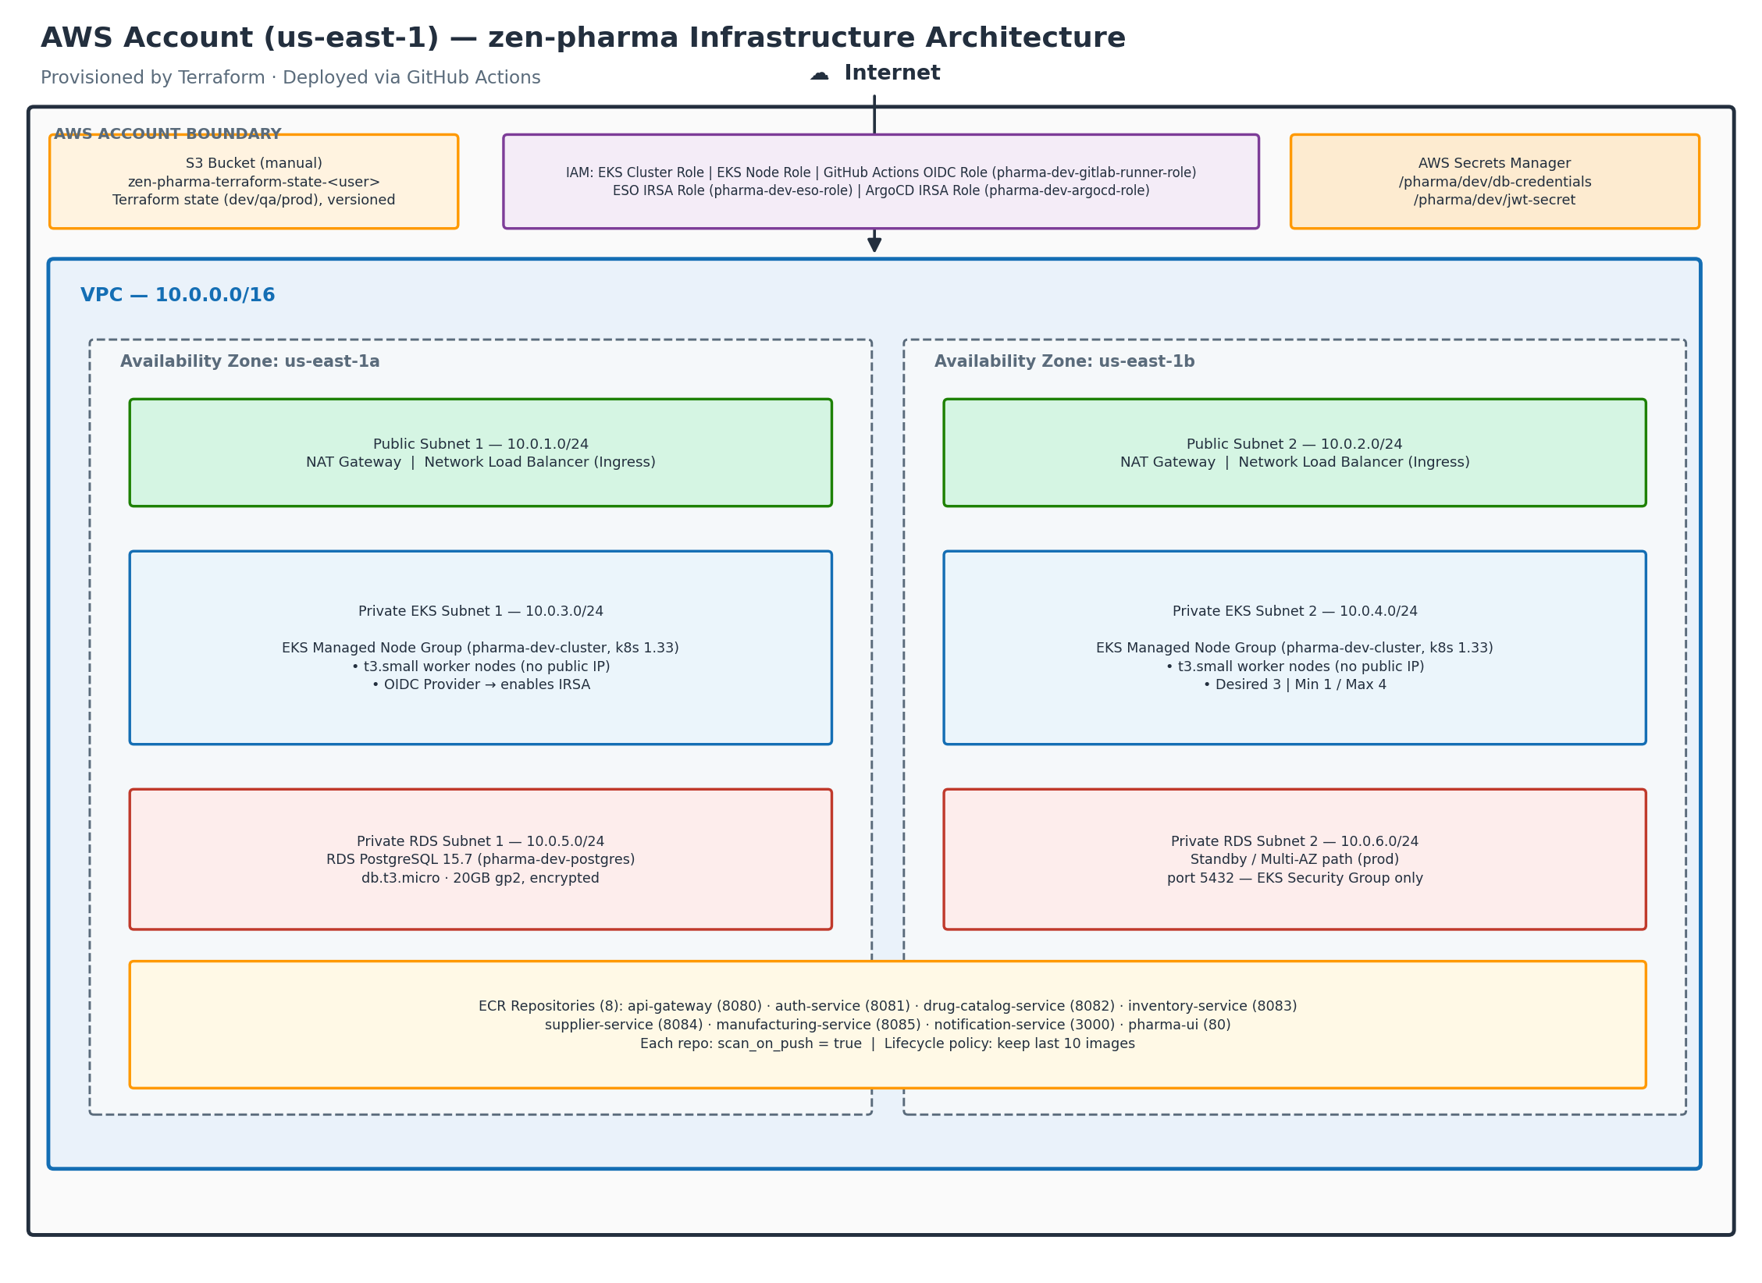
Figure 1. AWS resources created by Terraform for zen-infra (dev environment) — VPC, subnets, EKS, RDS, ECR, IAM, and Secrets Manager.

AWS Resources Created by Terraform
AWS Account (us-east-1)
|
+-- S3 Bucket (created manually - state backend for Terraform)
| +-- zen-pharma-terraform-state-<your-username>
| +-- envs/dev/terraform.tfstate
| +-- envs/qa/terraform.tfstate
| +-- envs/prod/terraform.tfstate
|
+-- VPC (10.0.0.0/16)
| +-- Public Subnets 10.0.1.0/24 (us-east-1a) ] NAT Gateway,
| | 10.0.2.0/24 (us-east-1b) ] NLB, Ingress
| +-- Private EKS Subnets 10.0.3.0/24 (us-east-1a) ] EKS worker
| | 10.0.4.0/24 (us-east-1b) ] nodes (private)
| +-- Private RDS Subnets 10.0.5.0/24 (us-east-1a) ] RDS PostgreSQL
| 10.0.6.0/24 (us-east-1b) ] (private)
|
+-- EKS Cluster (pharma-dev-cluster, Kubernetes 1.33)
| +-- Managed Node Group
| | +-- Instance type : t3.small
| | +-- Desired : 3 nodes
| | +-- Min / Max : 1 / 4
| | +-- Subnets : private EKS subnets (no public IP)
| +-- OIDC Provider
| +-- Enables IRSA - pods assume IAM roles without static credentials
|
+-- RDS PostgreSQL (pharma-dev-postgres)
| +-- Engine : PostgreSQL 15.7
| +-- Instance : db.t3.micro
| +-- Storage : 20 GB gp2, encrypted
| +-- Access : private subnet only, port 5432 from EKS SG only
| +-- DB name : pharmadb / Master user: pharmaadmin
|
+-- ECR Repositories (8 repos, one per service)
| +-- api-gateway (Spring Cloud Gateway, port 8080)
| +-- auth-service (JWT auth, port 8081)
| +-- drug-catalog-service (drug catalogue, port 8082)
| +-- inventory-service (stock management, port 8083)
| +-- supplier-service (vendor management, port 8084)
| +-- manufacturing-service (batch tracking, port 8085)
| +-- notification-service (Node.js, port 3000)
| +-- pharma-ui (React frontend, port 80)
| |
| +-- Each repo has:
| +-- scan_on_push = true (automatic CVE scan on every push)
| +-- Lifecycle policy (keep last 10 images, expire older ones)
|
+-- IAM
| +-- EKS Cluster Role (allows EKS control plane to manage AWS resources)
| +-- EKS Node Group Role (allows worker nodes to pull from ECR, join cluster)
| |
| +-- GitHub Actions OIDC Role (pharma-dev-gitlab-runner-role)
| | +-- Trust policy : repo zen-pharma-frontend and zen-pharma-backend only
| | +-- Permissions : ECR push/pull, EKS describe
| | +-- How it works : GitHub OIDC token -> AWS STS -> short-lived credentials
| | No AWS_ACCESS_KEY_ID stored in GitHub
| |
| +-- ESO IRSA Role (pharma-dev-eso-role)
| | +-- Trust policy : EKS service account external-secrets/external-secrets
| | +-- Permissions : secretsmanager:GetSecretValue on /pharma/* paths only
| |
| +-- ArgoCD IRSA Role (pharma-dev-argocd-role)
| +-- Trust policy : EKS service account argocd/argocd-application-controller
|
+-- AWS Secrets Manager
+-- /pharma/dev/db-credentials {"username": "pharmaadmin", "password": "..."}
+-- /pharma/dev/jwt-secret {"secret": "..."}

Terraform Module Structure
zen-infra/
+-- envs/
| +-- dev/ <-- calls all modules with dev-specific values
| +-- qa/ <-- same modules, different sizing
| +-- prod/ <-- same modules, production sizing + HA settings
|
+-- modules/
+-- vpc/ creates VPC, subnets, IGW, NAT GW, route tables
+-- eks/ creates EKS cluster, node group, OIDC provider
+-- rds/ creates RDS instance, subnet group, security group
+-- ecr/ creates ECR repos with lifecycle policies
+-- iam/ creates OIDC roles for GitHub Actions, ESO, ArgoCD
+-- secrets-manager/ stores DB password and JWT secret in Secrets Manager

Each environment directory (envs/dev) calls the modules like functions:
envs/dev/main.tf
|
|-- module "vpc" --> modules/vpc/
|-- module "eks" --> modules/eks/ (depends on vpc outputs)
|-- module "rds" --> modules/rds/ (depends on vpc + eks outputs)
|-- module "ecr" --> modules/ecr/
|-- module "iam" --> modules/iam/ (depends on eks OIDC outputs)
+-- module "secrets_manager" --> modules/secrets-manager/

Modules share data via outputs — for example, module.eks.oidc_provider_arn is passed into module.iam so the IAM trust policy references the exact OIDC provider created for this cluster, not a hardcoded ARN.

Network Traffic Flow
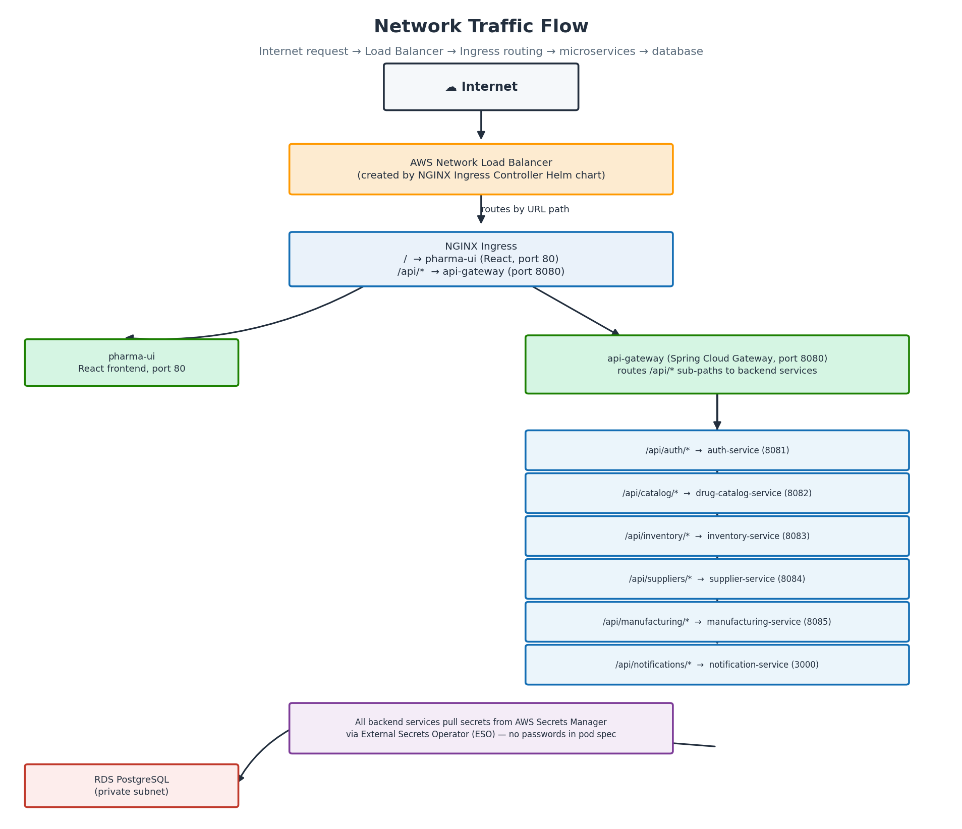
Figure 2. Ingress-based request routing from the Internet through the NLB and NGINX Ingress to backend microservices and RDS.
Internet
|
v
AWS Network Load Balancer (created by NGINX Ingress Controller Helm chart)
| routes by URL path
|-- / --> pharma-ui (React, port 80)
|-- /api/* --> api-gateway (port 8080)
|
|-- /api/auth/* --> auth-service (8081)
|-- /api/catalog/* --> drug-catalog-svc (8082)
|-- /api/inventory/* --> inventory-service (8083)
|-- /api/suppliers/* --> supplier-service (8084)
|-- /api/manufacturing/* --> manufacturing-svc (8085)
+-- /api/notifications/* --> notification-svc (3000)
|
All backend services
pull secrets from
AWS Secrets Manager
via ESO (no passwords
in pod spec or config)
|
v
RDS PostgreSQL (private subnet)

GitHub Actions CI/CD Flow for Infrastructure
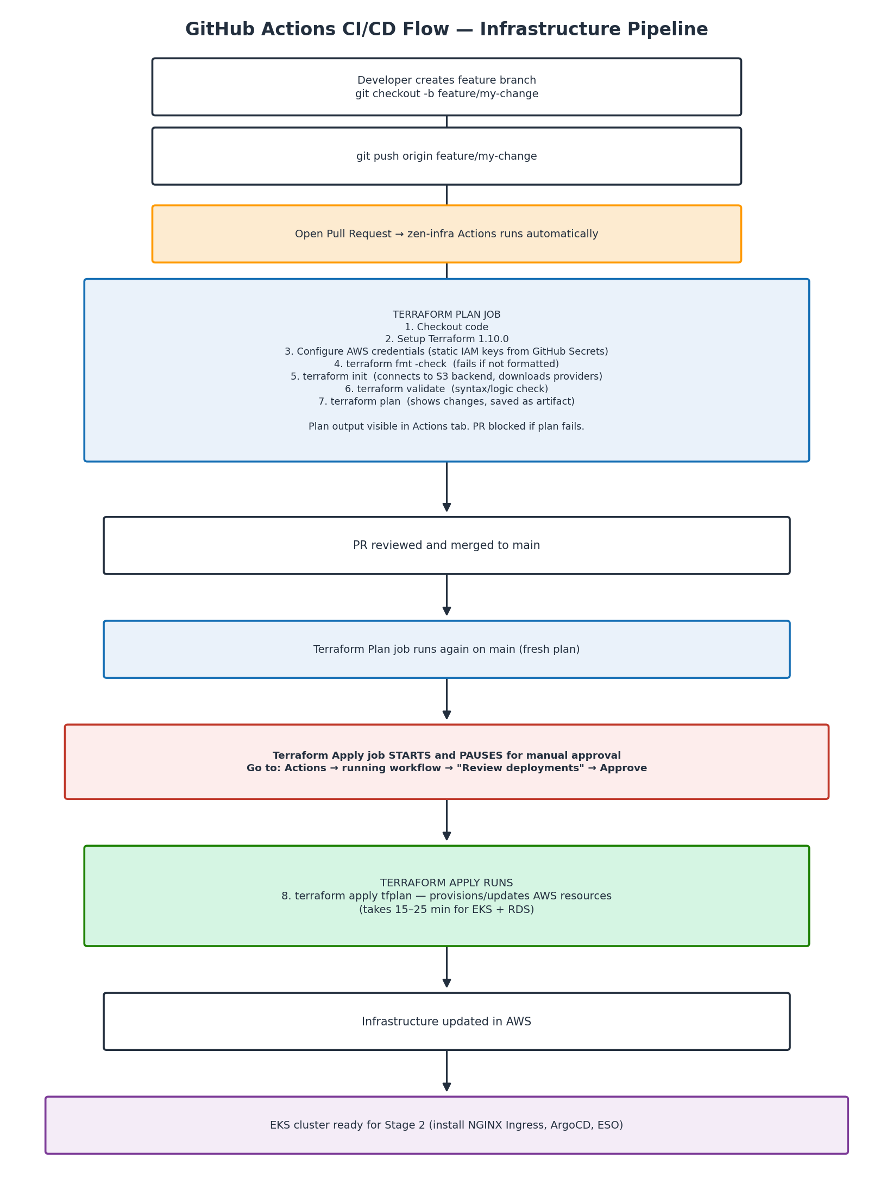
Figure 3. Infrastructure pipeline: plan on PR, plan again on merge, then a manually-approved apply.
Developer creates feature branch in zen-infra
|
v
git push origin feature/my-change
|
v
Open Pull Request --> zen-infra GitHub Actions runs automatically:
|
| [Terraform Plan job]
| 1. Checkout code
| 2. Setup Terraform 1.10.0
| 3. Configure AWS credentials (static IAM keys from GitHub Secrets)
| 4. terraform fmt -check --> fails if code is not formatted
| 5. terraform init --> connects to S3 backend, downloads providers
| 6. terraform validate --> syntax and logic check
| 7. terraform plan --> shows what will change (saved as artifact)
|
| Plan output is visible in the Actions tab. PR is blocked if plan fails.
|
v
PR reviewed and merged to main
|
v
[Terraform Plan job runs again on main - fresh plan]
|
v
[Terraform Apply job - PAUSES for manual approval]
|
| Go to: Actions --> running workflow --> "Review deployments" --> Approve
|
v
[Terraform Apply runs]
| 8. terraform apply tfplan --> provisions/updates AWS resources
| (takes 15-25 min for EKS + RDS)
|
v
Infrastructure updated in AWS
|
v
EKS cluster is ready for Stage 2 (install NGINX Ingress, ArgoCD, ESO)

Security Design Decisions
Decision | Why
Worker nodes in private subnets | Nodes not reachable from internet; only NLB is public
RDS in private subnets | Database never exposed to internet; only EKS nodes can connect (port 5432 via SG rule)
No static AWS keys in GitHub CI | GitHub Actions uses OIDC; credentials are short-lived (1 hour) and scoped to specific repos
IRSA for pods | Pods never hold AWS credentials; they exchange a projected K8s token for short-lived STS credentials
Secrets Manager (not ConfigMap) | DB passwords and JWT secret never live in Git or Kubernetes config; ESO syncs them at runtime
ECR scan on push | Every image is automatically scanned for CVEs when pushed; results visible in ECR console
S3 state with versioning | Terraform state is versioned — accidental corruption can be rolled back

2. Prerequisites
Ensure the following tools are installed on your local machine before starting.

Required Tools
Tool | Minimum Version | Install
Terraform | 1.10.0+ | https://developer.hashicorp.com/terraform/install
AWS CLI | 2.x | https://docs.aws.amazon.com/cli/latest/userguide/install-cliv2.html
Git | 2.x | https://git-scm.com/downloads

Verify Installations
terraform version
# Terraform v1.10.x

aws --version
# aws-cli/2.x.x

git --version
# git version 2.x.x

Required Access
- An AWS account with administrator access (or sufficient permissions — see Step 1)
- A GitHub account
- The zen-infra repository forked to your GitHub account

3. Repository Structure
zen-infra/
+-- .github/
| +-- dependabot.yml # Automated dependency update config
| +-- workflows/
| +-- terraform.yml # CI/CD pipeline - plan + apply + destroy
|
+-- envs/
| +-- dev/
| | +-- backend.tf # S3 remote state config for dev
| | +-- providers.tf # AWS, Kubernetes, TLS provider config
| | +-- main.tf # Module calls with dev-specific values
| | +-- variables.tf # Input variable declarations
| | +-- outputs.tf # Output values (cluster name, RDS endpoint)
| +-- qa/ # QA environment (structure mirrors dev)
| +-- prod/ # Prod environment (structure mirrors dev)
|
+-- modules/
+-- vpc/ # VPC, subnets, IGW, NAT Gateway, route tables
+-- eks/ # EKS cluster, node group, OIDC provider
+-- rds/ # RDS PostgreSQL, subnet group, security group
+-- ecr/ # ECR repositories and lifecycle policies
+-- iam/ # GitHub Actions OIDC role and policy
+-- secrets-manager/ # Secrets Manager secrets for app credentials

Key design decisions:
- Directory-per-environment (envs/dev, envs/qa, envs/prod) — complete isolation, separate state files, different resource sizing per environment
- Shared modules — all environments call the same modules with different input values
- No terraform.tfvars — secrets are never stored on disk, passed at runtime from GitHub Secrets

4. Step 1 — AWS Account Setup

4.1 Create an IAM User for Terraform (if not using OIDC)
For the initial bootstrap (before OIDC is set up via Terraform), you need an IAM user with programmatic access.
Go to AWS Console → IAM → Users → Create user:
- Username: terraform-ci
- Access type: Programmatic access
- Permissions: Attach the following managed policies:
  - AdministratorAccess (simplest for learning — scope down in production)
Save the Access Key ID and Secret Access Key — you will need these in Step 5.
Note: For production: Scope IAM permissions to only what Terraform needs — EC2, EKS, RDS, ECR, IAM, Secrets Manager, S3, VPC.

4.2 Configure AWS CLI Locally
aws configure
# AWS Access Key ID: <your-access-key-id>
# AWS Secret Access Key: <your-secret-access-key>
# Default region name: us-east-1
# Default output format: json

Verify it works:
aws sts get-caller-identity
# Should return your account ID, user ARN, and user ID

5. Step 2 — S3 State Backend Setup
Terraform requires an S3 bucket to store its state file. This bucket must exist before running Terraform. Create it manually — you only do this once.

5.1 Create the S3 Bucket
Replace YOUR-GITHUB-USERNAME with your actual GitHub username to make the bucket name unique.
# Create the bucket
aws s3api create-bucket \
--bucket zen-pharma-terraform-state-YOUR-GITHUB-USERNAME \
--region us-east-1

# Enable versioning (allows state rollback)
aws s3api put-bucket-versioning \
--bucket zen-pharma-terraform-state-YOUR-GITHUB-USERNAME \
--versioning-configuration Status=Enabled

# Enable encryption
aws s3api put-bucket-encryption \
--bucket zen-pharma-terraform-state-YOUR-GITHUB-USERNAME \
--server-side-encryption-configuration '{
"Rules": [{
"ApplyServerSideEncryptionByDefault": {
"SSEAlgorithm": "AES256"
}
}]
}'

# Block all public access
aws s3api put-public-access-block \
--bucket zen-pharma-terraform-state-YOUR-GITHUB-USERNAME \
--public-access-block-configuration \
"BlockPublicAcls=true,IgnorePublicAcls=true,BlockPublicPolicy=true,RestrictPublicBuckets=true"

5.2 Verify the Bucket
aws s3 ls s3://zen-pharma-terraform-state-YOUR-GITHUB-USERNAME
# Should return empty (no error)

6. Step 3 — Fork and Configure the Repository

6.1 Fork the Repository
- Go to github.com/your-github-username/zen-infra
- Click Fork (top right)
- Select your account as the destination
- Clone your fork locally:
git clone https://github.com/YOUR-GITHUB-USERNAME/zen-infra.git
cd zen-infra

7. Step 4 — Update Configuration for Your Account
You need to update four files to point to your S3 bucket and GitHub username.

7.1 Update Backend Configuration
Update the bucket name in all three environment backend files:
envs/dev/backend.tf
terraform {
backend "s3" {
bucket = "zen-pharma-terraform-state-YOUR-GITHUB-USERNAME"
key = "envs/dev/terraform.tfstate"
region = "us-east-1"
encrypt = true
use_lockfile = true
}
}

envs/qa/backend.tf — same change, key stays envs/qa/terraform.tfstate
envs/prod/backend.tf — same change, key stays envs/prod/terraform.tfstate

7.2 Update GitHub Organisation Variable
In envs/dev/variables.tf, update the default value for github_org:
variable "github_org" {
description = "GitHub username or organization"
type = string
default = "YOUR-GITHUB-USERNAME" # <- change this
}

Do the same in envs/qa/variables.tf and envs/prod/variables.tf.

7.3 Update the GitHub Actions Workflow
In .github/workflows/terraform.yml, update the github_org value:
- name: Terraform Plan
run: |
terraform plan \
-var="db_password=${{ secrets.DEV_DB_PASSWORD }}" \
-var="jwt_secret=${{ secrets.DEV_JWT_SECRET }}" \
-var="github_org=YOUR-GITHUB-USERNAME" \ # <- change this
-out=tfplan \
-no-color

7.4 Commit and Push Changes
git add envs/dev/backend.tf envs/qa/backend.tf envs/prod/backend.tf
git add envs/dev/variables.tf envs/qa/variables.tf envs/prod/variables.tf
git add .github/workflows/terraform.yml
git commit -m "config: update bucket name and github org for my account"
git push origin main

8. Step 5 — GitHub Secrets Setup
The pipeline needs AWS credentials and application secrets to run Terraform. These are stored as encrypted GitHub Secrets — never in code.

8.1 Add Repository Secrets
Go to your fork on GitHub: Settings → Secrets and variables → Actions → New repository secret
Add the following secrets:
Secret Name | Value | Description
AWS_ACCESS_KEY_ID | Your IAM user access key ID | AWS authentication for Terraform
AWS_SECRET_ACCESS_KEY | Your IAM user secret access key | AWS authentication for Terraform
DEV_DB_PASSWORD | A strong password (min 8 chars) | RDS PostgreSQL master password
DEV_JWT_SECRET | A long random string | JWT signing secret for the app

Generating a strong random secret:
# Generate a random JWT secret
openssl rand -hex 32

Note: Once set, these values are never visible again in the GitHub UI. Store them in a password manager.

9. Step 6 — GitHub Environment Setup
GitHub Environments add an approval gate before terraform apply runs. This ensures a human reviews the plan before infrastructure changes are applied.

9.1 Create the Dev Environment
Go to your fork on GitHub: Settings → Environments → New environment
- Name: dev
- Click Configure environment

9.2 Add Required Reviewer
Under Deployment protection rules:
- Check Required reviewers
- Search for and add your GitHub username
- Leave Prevent self-review unchecked (you are a solo learner)
- Click Save protection rules

9.3 What This Does
When the pipeline runs after a merge to main:
- 1. The plan job runs automatically
- 2. The apply job starts but pauses — GitHub shows a "Review deployments" button
- 3. You review the plan in the Actions logs
- 4. You click Approve and deploy
- 5. terraform apply runs
This prevents accidental infrastructure changes — even if bad code merges to main, a human must approve before anything changes in AWS.

10. Step 7 — Provision Infrastructure via Pipeline
With everything configured, you are ready to provision the infrastructure.

10.1 Create a Feature Branch
Never push directly to main for infrastructure changes. Use a PR:
git checkout -b feature/initial-setup

Make a small change to trigger the pipeline — for example, add a comment to envs/dev/main.tf:
# Initial dev environment setup
data "aws_caller_identity" "current" {}

git add envs/dev/main.tf
git commit -m "feat: initial dev environment setup"
git push origin feature/initial-setup

10.2 Open a Pull Request
Go to your fork on GitHub and open a PR from feature/initial-setup → main.
The Terraform Plan job will run automatically. After a few minutes, check the Actions tab to see the plan output. Verify:
- Plan: X to add, 0 to change, 0 to destroy
- No unexpected changes or errors

10.3 Merge the PR
Once the plan looks correct, merge the PR. This triggers the pipeline on main:
- 1. Plan job runs again (fresh plan on merge)
- 2. Apply job starts and pauses for approval
- 3. Go to Actions → the running workflow → Review deployments
- 4. Click Approve and deploy

10.4 Wait for Apply to Complete
The apply will take 15–25 minutes because:
- EKS cluster creation: ~10 minutes
- EKS node group provisioning: ~5 minutes
- RDS instance creation: ~5 minutes
Warning: Do not cancel the job — a cancelled mid-apply leaves partial state.
Monitor progress in Actions → the running workflow → Terraform Apply step.

11. Step 8 — Verify the Infrastructure
After apply completes, verify everything was created correctly.

11.1 Check Terraform Outputs
The apply job logs will show outputs at the end:
Apply complete! Resources: 45 added, 0 changed, 0 destroyed.

Outputs:

eks_cluster_name = "pharma-dev-cluster"
rds_endpoint = "pharma-dev-postgres.xxxxxxxx.us-east-1.rds.amazonaws.com"

11.2 Verify in AWS Console

EKS:
- Go to AWS Console → EKS → Clusters
- Verify pharma-dev-cluster is Active
- Click the cluster → Compute tab → verify node group shows 3 nodes Ready

RDS:
- Go to AWS Console → RDS → Databases
- Verify pharma-dev-postgres is Available

ECR:
- Go to AWS Console → ECR → Repositories
- Verify 5 repositories exist: api-gateway, auth-service, pharma-ui, notification-service, drug-catalog-service

Secrets Manager:
- Go to AWS Console → Secrets Manager
- Verify /pharma/dev/db-credentials and /pharma/dev/jwt-secret exist
Note: Screenshot placeholder — this run book cannot generate genuine AWS Console screenshots without a live account. During execution, capture and paste an actual screenshot at each of the four checkpoints above (EKS Clusters list, RDS Databases list, ECR Repositories list, Secrets Manager list) directly beneath the corresponding bullet list, so the completed run book serves as verifiable evidence of the POC.

11.3 Connect to the EKS Cluster Locally
# Update local kubeconfig
aws eks update-kubeconfig \
--region us-east-1 \
--name pharma-dev-cluster

# Verify connection
kubectl get nodes
# Should show 3 nodes in Ready state

kubectl get namespaces
# Should show default, kube-system, kube-public, kube-node-lease

12. Infrastructure Details

12.1 Networking
Resource | Value | Purpose
VPC CIDR | 10.0.0.0/16 | Main network
Public Subnet 1 | 10.0.1.0/24 (us-east-1a) | NAT Gateway, Load Balancers
Public Subnet 2 | 10.0.2.0/24 (us-east-1b) | NAT Gateway, Load Balancers
Private EKS Subnet 1 | 10.0.3.0/24 (us-east-1a) | EKS worker nodes
Private EKS Subnet 2 | 10.0.4.0/24 (us-east-1b) | EKS worker nodes
Private RDS Subnet 1 | 10.0.5.0/24 (us-east-1a) | RDS PostgreSQL
Private RDS Subnet 2 | 10.0.6.0/24 (us-east-1b) | RDS PostgreSQL

Worker nodes and RDS are in private subnets — no direct internet access. Outbound traffic routes through the NAT Gateway.

12.2 EKS Cluster
Setting | Dev Value | Notes
Cluster version | 1.33 | Update periodically
Node instance type | t3.small | Cost-optimised for dev
Desired nodes | 3 | Adjust based on workload
Min nodes | 2 | Minimum for HA
Max nodes | 4 | Auto-scaling ceiling
OIDC provider | Enabled | Required for IRSA

12.3 RDS PostgreSQL
Setting | Dev Value | Prod Value
Engine version | 15.7 | 15.7
Instance class | db.t3.micro | Larger (db.t3.medium+)
Storage | 20 GB gp2 | More, with autoscaling
Multi-AZ | No | Yes
Backup retention | 0 days | 7 days
Deletion protection | No | Yes
Encryption | Yes | Yes
Public access | No | No

RDS is only accessible from EKS worker nodes via the security group — port 5432 from the EKS cluster security group only.

12.4 ECR Repositories
All 5 repositories have:
- image_tag_mutability = MUTABLE — allows overwriting tags (useful in dev)
- scan_on_push = true — automatic vulnerability scanning on every push
- Lifecycle policy: keep last 10 images, expire older ones automatically

12.5 GitHub Actions OIDC
The IAM module creates a GitHub Actions OIDC role that allows CI/CD pipelines in zen-pharma-frontend and zen-pharma-backend to push images to ECR without storing AWS credentials in GitHub Secrets.
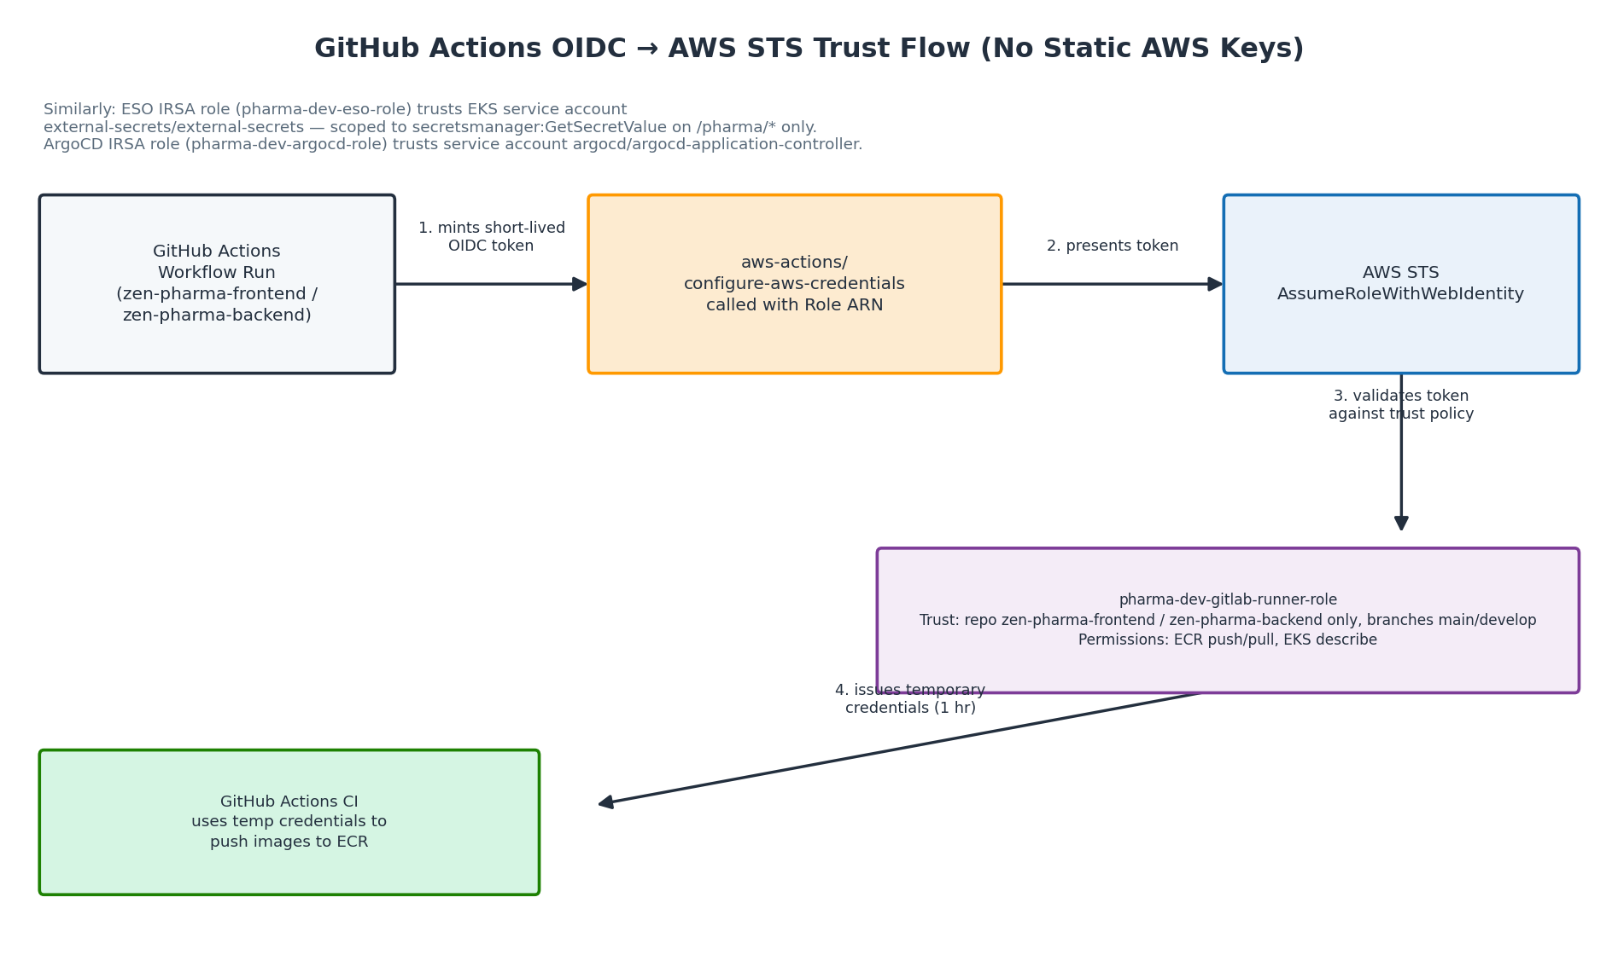
Figure 4. GitHub OIDC token exchanged for short-lived AWS STS credentials via the IAM trust policy.
How it works:
- 1. GitHub mints a short-lived OIDC token per workflow run
- 2. The workflow calls aws-actions/configure-aws-credentials with the role ARN
- 3. AWS validates the token and issues temporary STS credentials (1 hour)
- 4. CI uses these credentials to push images to ECR
The role is restricted to:
- Only YOUR-GITHUB-USERNAME/zen-pharma-frontend and YOUR-GITHUB-USERNAME/zen-pharma-backend repos
- Only main and develop branches

13. Day-2 Operations

Making Infrastructure Changes
Always use the PR-based flow:
# 1. Create a branch
git checkout -b feature/your-change

# 2. Make your Terraform changes
# Edit files in envs/dev/ or modules/

# 3. Test locally first
cd envs/dev
terraform init
terraform plan \
-var="db_password=test" \
-var="jwt_secret=test"

# 4. Push and open a PR
git add .
git commit -m "describe your change"
git push origin feature/your-change
# Open PR on GitHub -> plan runs automatically

# 5. Review the plan in Actions logs
# 6. Merge if plan is correct -> approve apply

Scaling the EKS Node Group
Edit envs/dev/main.tf:
module "eks" {
...
desired_capacity = 5 # <- change this
min_size = 3
max_size = 8
}

Open a PR, review the plan (should show EKS node group update), merge, approve apply.

Adding a New ECR Repository
Edit envs/dev/main.tf:
module "ecr" {
...
repositories = [
"api-gateway",
"auth-service",
"pharma-ui",
"notification-service",
"drug-catalog-service",
"new-service" # <- add here
]
}

Plan will show 2 new resources: aws_ecr_repository.main["new-service"] and its lifecycle policy.

Checking State
cd envs/dev

# List all resources in state
terraform state list

# Inspect a specific resource
terraform state show module.eks.aws_eks_cluster.main

# Check for drift (what changed in AWS outside Terraform)
terraform plan \
-var="db_password=dummy" \
-var="jwt_secret=dummy"

14. Destroying Infrastructure
Warning: This permanently deletes all infrastructure including the EKS cluster, RDS database, and all data. There is no undo.

Via Pipeline (Recommended)
- 1. Go to your fork on GitHub → Actions
- 2. Select Terraform Infrastructure workflow
- 3. Click Run workflow
- 4. Set:
  - Terraform action: destroy
  - Type "destroy" to confirm: destroy
- 5. Click Run workflow
- 6. The destroy job will pause for approval — review then approve
- 7. Wait 15–25 minutes for all resources to be deleted

Locally (Alternative)
cd envs/dev
terraform init
terraform destroy \
-var="db_password=dummy" \
-var="jwt_secret=dummy" \
-var="github_org=YOUR-GITHUB-USERNAME"

Type yes when prompted.

After Destroying
The S3 state bucket is not deleted by Terraform destroy — it is managed separately. To delete it:
# Empty the bucket first
aws s3 rm s3://zen-pharma-terraform-state-YOUR-GITHUB-USERNAME --recursive

# Delete the bucket
aws s3api delete-bucket \
--bucket zen-pharma-terraform-state-YOUR-GITHUB-USERNAME \
--region us-east-1

15. Troubleshooting

Plan shows resources already exist (RepositoryAlreadyExistsException)
ECR repositories cannot be destroyed if they contain images. If you recreated the stack after a destroy, images may still exist in the repos.

Fix — delete repos manually then re-run:
for repo in api-gateway auth-service pharma-ui notification-service drug-catalog-service; do
aws ecr delete-repository \
--repository-name $repo \
--force \
--region us-east-1
done

Then re-trigger the pipeline.

Apply failed halfway through
Do not panic. Terraform updates state for every resource it successfully creates.
- 1. Read the error in the Actions logs (expand the Apply step, scroll up from the bottom)
- 2. Fix the root cause
- 3. Re-trigger the pipeline — it will continue from where it left off

State lock error
Error: Error acquiring the state lock

Another apply is running (or a previous one crashed mid-run). Wait for it to finish. If you are certain no apply is running:
cd envs/dev
terraform force-unlock <LOCK-ID>
# Lock ID is shown in the error message

terraform init fails — bucket does not exist
You have not created the S3 bucket yet. Follow Step 2 (Section 5 of this run book).

EKS nodes not joining the cluster
kubectl get nodes
# Shows nodes in NotReady state

Check node group IAM role has the required policies:
- AmazonEKSWorkerNodePolicy
- AmazonEKS_CNI_Policy
- AmazonEC2ContainerRegistryReadOnly
These are attached automatically by Terraform. If nodes are not joining, the apply may not have completed fully — check the apply logs.

Pipeline apply job is skipped
The apply job only runs on:
- Push/merge to main when envs/dev/** or modules/** files changed
- Manual workflow_dispatch with action: apply
If you only changed workflow files (.github/workflows/), the paths filter prevents the pipeline from triggering.

Cannot connect to EKS cluster locally
# Re-fetch credentials
aws eks update-kubeconfig --region us-east-1 --name pharma-dev-cluster

# Check your AWS identity
aws sts get-caller-identity

# Verify cluster is active
aws eks describe-cluster --name pharma-dev-cluster --query 'cluster.status'

Only the IAM entity that created the cluster (the CI/CD role or your local user) has access by default. If using a different IAM user locally, you need to add it to the EKS aws-auth ConfigMap.

16. Cost Estimate (Dev Environment)
Resource | Approximate Cost
EKS Cluster | ~$0.10/hour (~$72/month)
3x t3.small EC2 nodes | ~$0.06/hour (~$43/month)
RDS db.t3.micro | ~$0.02/hour (~$14/month)
NAT Gateway | ~$0.045/hour (~$32/month) + data transfer
ECR Storage | ~$0.10/GB/month (minimal)
Secrets Manager | ~$0.40/secret/month (2 secrets = ~$0.80)
Total estimate | ~$160–180/month

Note: For learners: Destroy the infrastructure when not in use. EKS and NAT Gateway are the largest costs. Use the destroy pipeline at the end of each day and re-provision when needed.
This guide covers the dev environment. QA and prod environments follow the same setup process — create the GitHub environments with appropriate protection rules and add the corresponding secrets (QA_DB_PASSWORD, QA_JWT_SECRET, etc.).

17. Interview Preparation
After completing this lab you have built and deployed real infrastructure — not watched a demo. Dedicated interview preparation documents are available in the docs/ folder:
- Terraform Interview Questions — 40 questions covering core concepts, state management, modules, CI/CD pipeline, and real-world scenarios with zen-infra references (github.com/zenpharma/infra/blob/main/docs/terraform-interview-questions.md)
- GitHub Actions Interview Questions — coming soon
Built with Terraform 1.10+ · GitHub Actions · AWS EKS, RDS, ECR, VPC, IAM, Secrets Manager

=====================================================================================

PART 2 — Azure DevOps / Azure Equivalent
The zenpharma/infra repository is written for AWS (Terraform + GitHub Actions). This part of the run book provides a like-for-like translation of the same platform onto Microsoft Azure, using Azure Kubernetes Service (AKS), Azure Database for PostgreSQL, Azure Container Registry (ACR), Microsoft Entra ID Workload Identity, Azure Key Vault, and Azure DevOps Pipelines. Every AWS concept, resource, and pipeline stage in Part 1 has a direct Azure counterpart below, preserving the same architecture, security model, and operational flow.
=======================================================================
Notes on AKS from Udemy .NET Microservices Project with AKS –

Course: .NET Microservices with Azure DevOps & AKS | Basic to Master | Udemy
Notes
=============================================================
Udemy Project –
https://www.udemy.com/course/dot-net-microservices-ecommerce-project-azure-devops-kubernetes-aks/learn/lecture/46567207#overview
Start from Section 12 – Intro to Azure Cloud -
Introduction to Kubernetes
Kubernetes (K8s) is an open-source platform designed to automate the deployment, scaling, and operation of containerized applications. It provides a robust framework for managing microservices architectures and large-scale applications.
=====================================================================================
What is Kubernetes?
- Definition: Kubernetes is a container orchestration platform that enables developers to automate the management of containerized applications. Containers encapsulate the application and its dependencies, making them portable and consistent across environments. Kubernetes helps to manage these containers in a clustered environment.
- Goals:
  - Automate Deployment: Kubernetes automates the deployment of containers to ensure that applications are distributed across the cluster as intended.
  - Scaling: Automatically scale applications based on demand, adding or removing instances of services as needed.
  - Maintain Availability: Ensure applications are highly available and resilient to failures.

Key Concepts
- Cluster:
  - A Kubernetes cluster consists of a set of nodes that run containerized applications. The cluster is managed by a master node (or control plane) which coordinates the worker nodes that run the application containers.
  - Components:
    - Master Node: Controls the Kubernetes cluster. It includes:
      - API Server: Manages API requests, validates, and processes them.
      - Controller Manager: Manages controllers that handle routine tasks, such as scaling deployments or managing replicas.
      - Scheduler: Assigns Pods to nodes based on resource availability.
      - etcd: A distributed key-value store used for storing cluster state and configuration.
    - Worker Nodes: Run application containers and include:
      - Kubelet: An agent that ensures containers are running as expected.
      - Kube Proxy: Handles network routing and load balancing for Pods.
      - Container Runtime: Software (like Docker) that runs containers.
- Pod:
  - The smallest deployable unit in Kubernetes. A Pod can contain one or more containers that share the same network namespace and storage. Pods are designed to run a single instance of a specific application.
- Service:
  - An abstraction that defines a logical set of Pods and a policy for accessing them. Services provide a stable endpoint for accessing Pods, which might be dynamic and change over time.
- Deployment:
  - Manages the deployment and scaling of Pods. It ensures the desired number of Pods are running and can perform rolling updates and rollbacks to maintain application consistency.
- ConfigMap and Secret:
  - ConfigMap: Manages non-sensitive configuration data. It allows you to decouple configuration artifacts from container images.
  - Secret: Manages sensitive data such as passwords, OAuth tokens, and SSH keys. Secrets are encoded in Base64 to prevent casual inspection.

Benefits of Kubernetes
- High Availability:
  - Kubernetes ensures that applications are always available by automatically distributing the load and replicating Pods across multiple nodes. If a node fails, Kubernetes reschedules Pods to other healthy nodes.
- Self-Healing:
  - Automatically replaces or restarts failed containers. It ensures that the desired state of the application is maintained even if failures occur.
- Automated Rollouts and Rollbacks:
  - Provides mechanisms for deploying application updates gradually and rolling back changes if something goes wrong. This helps in managing application updates with minimal disruption.
- Scalability:
  - Kubernetes allows horizontal scaling of applications by adding or removing Pods based on load. It supports both manual and automatic scaling based on predefined metrics.
- Declarative Configuration:
  - Allows you to describe the desired state of the system using YAML or JSON files. Kubernetes ensures that the current state matches the desired state specified in these configuration files.
- Service Discovery and Load Balancing:
  - Kubernetes automatically assigns a unique IP address and DNS name to each Service. It handles load balancing between Pods and provides service discovery mechanisms.

Use Cases
- Microservices Architecture:
  - Kubernetes is particularly suited for managing microservices-based applications where services are decoupled and interact through APIs. It helps in managing the deployment, scaling, and monitoring of these services.
- CI/CD Pipelines:
  - Integrates well with continuous integration and continuous deployment (CI/CD) systems. Kubernetes can automate the deployment of applications as part of the CI/CD pipeline.
- Hybrid Cloud Deployments:
  - Supports hybrid cloud environments where applications are deployed across on-premises and cloud-based infrastructure.

Key Points to Remember (For Interview Preparation)
- Kubernetes Overview: Understand the role of Kubernetes in container orchestration and its ability to automate deployment, scaling, and operation of applications.
- Cluster Architecture: Be familiar with the components of a Kubernetes cluster, including the master node, worker nodes, and their roles.
- Core Concepts: Know the basic Kubernetes objects such as Pods, Services, and Deployments, and how they interact.
- Benefits: Recognize the advantages of using Kubernetes, including high availability, self-healing, scalability, and automated updates.
- Use Cases: Be able to explain typical scenarios where Kubernetes is beneficial, such as microservices architecture and CI/CD pipelines.

Problems with Kubernetes
While Kubernetes provides powerful capabilities for managing containerized applications, it comes with its own set of challenges and limitations. Understanding these issues is crucial for effectively implementing and operating Kubernetes in a real-world environment.
1. Complexity and Learning Curve
- Steep Learning Curve:
  - Kubernetes introduces many new concepts and components (like Pods, Services, Deployments, etc.), which can be overwhelming for newcomers. The complexity of Kubernetes architecture demands significant time and effort to understand and operate effectively.
- Complex Configuration:
  - Kubernetes configurations (typically defined in YAML files) can be intricate and prone to human error. Debugging issues related to configuration can be time-consuming.
- Diverse Ecosystem:
  - The Kubernetes ecosystem includes various tools and add-ons (e.g., Helm for package management, Prometheus for monitoring). Managing and integrating these tools can add to the overall complexity.
2. Resource Consumption
- High Resource Overhead:
  - Kubernetes itself requires resources to run, including the master components and agents on each node. This overhead can be substantial, particularly in smaller clusters or on resource-constrained environments.
- Efficient Resource Utilization:
  - Ensuring efficient resource utilization (CPU, memory) within the cluster requires careful configuration of resource requests and limits. Poorly configured resource management can lead to inefficient use of cluster resources.
3. Operational Overhead
- Cluster Management:
  - Managing and maintaining a Kubernetes cluster involves regular updates, security patches, and backups. This operational overhead can be significant, especially for self-managed clusters.
- Troubleshooting:
  - Diagnosing issues in a Kubernetes cluster can be challenging due to the distributed nature of the system. Problems with Pods, Services, or networking can be hard to trace and resolve.
4. Security Concerns
- Access Control:
  - Kubernetes security requires proper configuration of Role-Based Access Control (RBAC) and Network Policies. Misconfigured access control can lead to security vulnerabilities.
- Secrets Management:
  - While Kubernetes provides mechanisms for managing sensitive information (Secrets), ensuring that secrets are handled securely and appropriately can be complex.
- Pod Security:
  - Securing Pods and containerized applications involves configuring security contexts and Pod Security Policies. Inadequate security configurations can expose applications to risks.
5. Networking Challenges
- Complex Networking:
  - Kubernetes networking involves managing internal and external traffic, Service discovery, and load balancing. Configuring and troubleshooting network issues can be complex.
- Service Discovery and Load Balancing:
  - Ensuring that Services are discovered correctly and load-balanced effectively across Pods can be challenging, especially in large or dynamic environments.
6. Persistent Storage
- Stateful Applications:
  - Managing persistent storage for stateful applications in Kubernetes can be complex. Kubernetes supports Persistent Volumes (PVs) and Persistent Volume Claims (PVCs), but configuring and managing storage can require additional effort.
- Data Migration and Backup:
  - Handling data migration and backup for applications running in Kubernetes needs to be carefully planned. Ensuring data durability and availability across cluster operations is crucial.
7. Integration with Existing Systems
- Legacy Systems:
  - Integrating Kubernetes with existing legacy systems and infrastructure can be challenging. Migrating applications from traditional environments to Kubernetes may require significant changes.
- Interoperability:
  - Ensuring interoperability between Kubernetes and other systems (e.g., databases, message brokers) can involve additional configuration and management.
8. Cost Management
- Cloud Costs:
  - Running Kubernetes on cloud platforms can incur substantial costs due to the need for multiple nodes, storage, and network resources. Effective cost management and optimization are essential.
- Operational Costs:
  - The operational costs of managing a Kubernetes cluster, including personnel, tools, and maintenance, can add up. Balancing these costs with the benefits is important for overall efficiency.

Key Points to Remember (For Interview Preparation)
- Complexity: Be aware of the complexity of Kubernetes and its steep learning curve. Understand that configuring and managing Kubernetes requires significant expertise.
- Resource Overhead: Recognize that Kubernetes introduces resource overhead and requires careful resource management to avoid inefficiencies.
- Operational Overhead: Acknowledge the operational overhead involved in managing and maintaining a Kubernetes cluster, including troubleshooting and security.
- Security: Understand the security concerns associated with Kubernetes, including access control, secrets management, and Pod security.
- Networking: Be familiar with the challenges related to Kubernetes networking, Service discovery, and load balancing.
- Persistent Storage: Know the complexities of managing persistent storage for stateful applications and data migration in Kubernetes.
- Integration and Costs: Be aware of the challenges in integrating Kubernetes with existing systems and managing costs associated with cloud and operational resources.

Introduction to AKS
Azure Kubernetes Service (AKS) is a managed container orchestration service provided by Microsoft Azure that simplifies the deployment, management, and scaling of containerized applications using Kubernetes. AKS abstracts much of the complexity associated with Kubernetes management, allowing you to focus on developing and running your applications.

1. Overview of AKS
- Managed Kubernetes Service:
  - AKS provides a managed Kubernetes environment, handling many of the operational aspects of Kubernetes, such as the control plane and cluster maintenance, which are managed by Azure.
- Integration with Azure Ecosystem:
  - AKS integrates seamlessly with other Azure services, such as Azure Container Registry (ACR) for container image storage, Azure Monitor for logging and monitoring, and Azure Active Directory (AAD) for identity and access management.
- Simplified Cluster Management:
  - AKS reduces the operational burden of managing Kubernetes clusters by automating tasks like upgrades, scaling, and security patching.

2. Key Features of AKS
- Automated Cluster Management:
  - Automatic Upgrades: AKS automates Kubernetes version upgrades, ensuring that your cluster is always up to date with the latest features and security patches.
  - Scaling: AKS supports both manual and automatic scaling of nodes and pods to accommodate varying workloads.
- Integrated Monitoring and Diagnostics:
  - Azure Monitor: Provides comprehensive monitoring and logging capabilities, allowing you to gain insights into cluster performance and diagnose issues.
  - Azure Log Analytics: Collects and analyzes log data from your AKS cluster to help with troubleshooting and performance optimization.
- Security and Compliance:
  - Azure Active Directory Integration: Allows you to manage Kubernetes access and permissions using Azure AD identities and roles.
  - Network Policies: AKS supports Kubernetes Network Policies to control traffic between pods and enhance security.
- Container Registry Integration:
  - Azure Container Registry (ACR): AKS integrates with ACR, allowing you to store and manage container images securely and efficiently.
- Developer Productivity:
  - DevOps Integration: AKS integrates with Azure DevOps and GitHub Actions for continuous integration and deployment (CI/CD) pipelines, enabling automated application deployments.
- Cost Management:
  - Pay-as-You-Go: AKS is billed based on the resources used, including virtual machines and storage. You only pay for the compute resources you consume, with no charge for the Kubernetes control plane.

3. Common Use Cases
- Microservices Architectures:
  - AKS is well-suited for deploying and managing microservices applications, providing scalability and isolation for different service components.
- Dev/Test Environments:
  - Developers and testers can use AKS to quickly spin up Kubernetes clusters for development and testing purposes, leveraging the managed nature of AKS to reduce setup and maintenance overhead.
- Production Workloads:
  - AKS supports running production-grade workloads with high availability and reliability, thanks to its integration with Azure's infrastructure and services.
- Hybrid and Multi-Cloud Scenarios:
  - AKS can be part of a hybrid cloud or multi-cloud strategy, allowing you to manage workloads across on-premises, Azure, and other cloud environments.

4. Getting Started with AKS
- Creating an AKS Cluster:
  - You can create an AKS cluster using the Azure Portal, Azure CLI, or ARM templates. The process involves specifying cluster configuration parameters such as node size, number of nodes, and Kubernetes version.
- Accessing the Cluster:
  - Once created, you can access the AKS cluster using kubectl, the Kubernetes command-line tool. You can configure kubectl to communicate with your AKS cluster using the Azure CLI or the Azure Portal.
- Deploying Applications:
  - Deploying applications to AKS involves creating Kubernetes manifests (Deployment, Service, ConfigMap, etc.) and applying them using kubectl. AKS provides a scalable and resilient environment for running containerized applications.

Key Points to Remember (For Interview Preparation)
- Managed Service: AKS is a managed Kubernetes service that simplifies cluster management by handling operational aspects such as upgrades and scaling.
- Integration: AKS integrates with other Azure services, including Azure Container Registry, Azure Monitor, and Azure Active Directory, enhancing its functionality and security.
- Automated Management: Features like automatic upgrades, scaling, and integrated monitoring reduce operational overhead and improve cluster management.
- Cost-Effective: AKS follows a pay-as-you-go pricing model, charging only for the resources you use without additional costs for the Kubernetes control plane.
- Use Cases: AKS is ideal for microservices architectures, development and testing environments, production workloads, and hybrid/multi-cloud scenarios.
- Getting Started: Creating and managing an AKS cluster involves using the Azure Portal, Azure CLI, or ARM templates, and deploying applications using Kubernetes manifests and kubectl.

Kubernetes Architecture
Understanding Kubernetes architecture is essential to grasp how AKS works, as AKS leverages this architecture to manage containerized applications at scale. Kubernetes architecture consists of several core components that enable it to schedule, manage, and orchestrate containers efficiently.

1. Key Components of Kubernetes
The Kubernetes architecture is divided into two primary sections: the Control Plane and the Worker Nodes. Let’s explore each of these in detail.
1. Control Plane:
The control plane is responsible for managing the overall cluster and orchestrating the worker nodes. It consists of several components, each with a specific role in managing the Kubernetes cluster.
- API Server (kube-apiserver):
  - The API Server is the entry point for all Kubernetes-related operations. It serves as the primary interface for users, applications, and administrators to interact with the Kubernetes cluster. All requests to the cluster (e.g., to create or delete resources like pods and services) go through the API server.
- Etcd:
  - Etcd is the key-value store used by Kubernetes to store all cluster data. This includes information about nodes, pods, services, configuration data, secrets, and more. Since Etcd stores the cluster's entire state, it plays a crucial role in ensuring the reliability and availability of the cluster.
- Controller Manager (kube-controller-manager):
  - The controller manager runs multiple controllers that are responsible for monitoring the state of the cluster and making necessary adjustments to reach the desired state. For example, the ReplicaSet controller ensures that the correct number of pod replicas are running at any given time.
- Scheduler (kube-scheduler):
  - The Kubernetes scheduler is responsible for assigning pods to nodes based on resource availability, policies, and constraints. It evaluates each pod’s resource requirements and schedules them on the appropriate worker nodes.

2. Worker Nodes:
Worker nodes are the machines (virtual or physical) where containers are deployed. Each worker node runs several components that allow it to communicate with the control plane and manage the running containers.
- Kubelet:
  - The kubelet is the primary agent running on each worker node. It is responsible for communicating with the API server, receiving instructions, and ensuring that the containers specified in the pod definitions are running as expected on the node.
- Kube-Proxy:
  - The kube-proxy is a network proxy that maintains network rules on each worker node. It enables communication between different services and pods, both within the node and across nodes. It also ensures that the networking environment supports Kubernetes services.
- Container Runtime:
  - The container runtime (e.g., Docker or containerd) is the software that actually runs containers on the worker node. It handles the downloading of container images and manages the lifecycle of containers.

2. Interaction Between Components
The control plane components work in tandem with the worker node components to ensure that the desired state of the cluster is always achieved and maintained. Here’s how these interactions typically work:
- Cluster State:
  - The desired state of the cluster (e.g., the number of replicas, services, and configurations) is stored in the etcd database.
- API Requests:
  - Administrators and developers interact with the Kubernetes API server to submit requests to the cluster, such as deploying new applications or scaling existing ones. The API server processes these requests and updates the etcd database.
- Controllers:
  - The controller manager continuously monitors the state stored in etcd. If the actual state of the cluster does not match the desired state (e.g., a pod is down or missing), the appropriate controller will take corrective actions, such as creating a new pod.
- Scheduling:
  - The scheduler monitors resource availability on the worker nodes and assigns pods to nodes that have the necessary resources to run the application. The kubelet on each worker node ensures that the assigned pods are running and communicates their status back to the API server.
- Networking:
  - Kube-proxy manages the network rules and ensures that services and pods can communicate with each other across nodes. It supports service discovery and load balancing.

3. Benefits of Kubernetes Architecture in AKS
- Scalability: Kubernetes can easily scale both horizontally (by adding more nodes) and vertically (by increasing node resources). AKS leverages this architecture to scale applications dynamically, ensuring they can handle varying loads.
- Resilience: By automatically rescheduling failed pods, AKS ensures high availability and resilience. The controller manager and scheduler work together to maintain the desired state of the application.
- Modularity: Kubernetes’ modular architecture allows you to use different components interchangeably. For example, you can switch between container runtimes or networking plugins as needed, which makes AKS adaptable to different use cases.
- Automation: The control plane components in Kubernetes automate most of the operational tasks, such as load balancing, scaling, and self-healing, which AKS extends to its managed services, reducing the administrative overhead.

4. AKS and Kubernetes Architecture
In AKS, the control plane is managed by Azure, meaning that Azure takes responsibility for maintaining the API server, etcd, scheduler, and controller manager. The worker nodes, however, are managed by you, allowing you to configure and scale them as necessary.
- Managed Control Plane:
  - AKS abstracts the complexity of managing the control plane, automating tasks like patching, upgrading, and scaling the control plane components.
- Customizable Worker Nodes:
  - You have full control over the worker nodes in AKS. You can specify the size, number, and configuration of these nodes based on your application requirements. You can also scale the nodes manually or use autoscaling features provided by AKS.

Key Points to Remember (For Interview Preparation)
- Control Plane vs Worker Nodes: Kubernetes architecture is divided into the control plane (which manages the cluster) and worker nodes (where containers are deployed).
- Control Plane Components: Key components like the API server, etcd, controller manager, and scheduler play crucial roles in ensuring the cluster’s desired state is maintained.
- Worker Node Components: The kubelet, kube-proxy, and container runtime (e.g., Docker) ensure that containers are running as expected on the worker nodes.
- AKS Managed Control Plane: AKS simplifies Kubernetes management by offering a fully managed control plane while giving you control over worker nodes.
- Resilience and Automation: Kubernetes' architecture enables self-healing, scalability, and automation, reducing the need for manual intervention in operational tasks.

5. Creating AKS Cluster (using CLI)
Creating an AKS (Azure Kubernetes Service) cluster using the Azure CLI involves a series of steps to set up and configure a Kubernetes cluster that is managed by Azure. This process allows you to deploy and manage containerized applications efficiently.

1. Prerequisites
Before creating an AKS cluster, ensure that you have the following:
- Azure CLI: Make sure the Azure CLI (az) is installed and up-to-date on your machine.
- Azure Subscription: An active Azure subscription to create and manage resources.
- Resource Group: An existing or new Azure resource group where your AKS cluster will be created.
Install Azure CLI:
- # For Windows:
- msiexec /i https://aka.ms/installazurecliwindows

- # For macOS:
- brew install azure-cli

- # For Linux:
- curl -sL https://aka.ms/InstallAzureCLIDeb | sudo bash

2. Authenticate to Azure
Before creating resources, log in to your Azure account using the Azure CLI:
- az login
This command opens a web browser for authentication. Follow the prompts to log in.

3. Create a Resource Group
A resource group is a logical container for Azure resources. If you don't already have a resource group, create one using the Azure CLI:
- az group create --name myResourceGroup --location eastus
Replace myResourceGroup with your desired resource group name and eastus with your preferred Azure region.

4. Create an AKS Cluster
To create an AKS cluster, use the az aks create command. This command allows you to specify various parameters for the cluster, including the name, resource group, and node configurations.
- az aks create \
- --resource-group myResourceGroup \
- --name myAKSCluster \
- --node-count 3 \
- --enable-addons monitoring \
- --generate-ssh-keys
Parameters:
- --resource-group: The resource group where the AKS cluster will be created.
- --name: The name of the AKS cluster.
- --node-count: The number of nodes in the cluster.
- --enable-addons: Optional. Enables specific add-ons like monitoring.
- --generate-ssh-keys: Generates SSH keys for node access.

5. Verify Cluster Creation
After creating the AKS cluster, you can verify its status using:
- az aks show --resource-group myResourceGroup --name myAKSCluster
To get detailed information about your cluster, including its version and configuration, use this command.

6. Connect to the AKS Cluster
To manage your AKS cluster, configure kubectl to use the cluster:
- az aks get-credentials --resource-group myResourceGroup --name myAKSCluster
This command downloads the cluster credentials and configures kubectl to interact with your AKS cluster.

7. Verify kubectl Configuration
Ensure that kubectl is correctly configured to interact with your AKS cluster:
- kubectl get nodes
This command lists all nodes in the cluster, confirming that your kubectl configuration is working.
Key Points to Remember (For Interview Preparation)
- Azure CLI Commands: Familiarize yourself with the az aks create command and its parameters for creating and configuring AKS clusters.
- Resource Group: Understand the role of resource groups in organizing Azure resources and how to create them.
- Cluster Configuration: Be aware of key parameters like node count and add-ons when creating an AKS cluster.
- Connecting to AKS: Know how to use az aks get-credentials to configure kubectl for managing your AKS cluster.
- Verification: Use commands like az aks show and kubectl get nodes to verify the cluster creation and connectivity.

All Important Commands of kubectl
kubectl is the command-line tool for interacting with Kubernetes clusters. It allows you to manage your applications and clusters efficiently. Below is a detailed overview of some essential kubectl commands, categorized by their use cases:

1. Cluster Management
- Check Cluster Info
  - kubectl cluster-info
Displays information about the Kubernetes cluster, including the master and services URLs.
- Get Cluster Nodes
  - kubectl get nodes
Lists all nodes in the cluster, providing their status and roles.
- Get Cluster Version
  - kubectl version
Shows the Kubernetes client and server versions.

2. Pod Management
- List Pods
  - kubectl get pods
Lists all pods in the current namespace. Use --all-namespaces to list pods across all namespaces.
- Describe Pod
  - kubectl describe pod <pod-name>
Provides detailed information about a specific pod, including events and status.
- Get Pod Logs
  - kubectl logs <pod-name>
Retrieves logs from a specific pod. Use --container <container-name> if the pod has multiple containers.
- Execute Command in Pod
  - kubectl exec -it <pod-name> -- <command>
Executes a command inside a specific pod. The -it flag is used for interactive commands.
- Delete Pod
  - kubectl delete pod <pod-name>
Deletes a specific pod. This is useful for restarting a pod by forcefully removing it.

3. Deployment Management
- Create Deployment
  - kubectl create deployment <deployment-name> --image=<image-name>
Creates a new deployment with the specified name and container image.
- List Deployments
  - kubectl get deployments
Lists all deployments in the current namespace.
- Scale Deployment
  - kubectl scale deployment <deployment-name> --replicas=<number>
Scales the number of replicas for a deployment to the specified number.
- Update Deployment
  - kubectl apply -f <deployment-file>.yaml
Applies changes to a deployment based on a YAML configuration file.
- Delete Deployment
  - kubectl delete deployment <deployment-name>
Deletes a specific deployment along with its pods.

4. Service Management
- List Services
  - kubectl get services
Lists all services in the current namespace.
- Describe Service
  - kubectl describe service <service-name>
Provides detailed information about a specific service, including its endpoints.
- Create Service
  - kubectl expose deployment <deployment-name> --port=<port> --target-port=<target-port> --name=<service-name>
Creates a service that exposes a deployment on the specified ports.
- Delete Service
  - kubectl delete service <service-name>
Deletes a specific service.

5. Namespace Management
- List Namespaces
  - kubectl get namespaces
Lists all namespaces in the cluster.
- Create Namespace
  - kubectl create namespace <namespace-name>
Creates a new namespace.
- Delete Namespace
  - kubectl delete namespace <namespace-name>
Deletes a specific namespace and its associated resources.

6. Config Management
- View Config Maps
  - kubectl get configmaps
Lists all config maps in the current namespace.
- Describe Config Map
  - kubectl describe configmap <configmap-name>
Provides detailed information about a specific config map.
- Create Config Map
  - kubectl create configmap <configmap-name> --from-literal=<key>=<value>
Creates a config map with the specified key-value pair.
- Delete Config Map
  - kubectl delete configmap <configmap-name>
Deletes a specific config map.
7. Secret Management
- List Secrets
  - kubectl get secrets
Lists all secrets in the current namespace.
- Create Secret
  - kubectl create secret generic <secret-name> --from-literal=<key>=<value>
Creates a new secret with the specified key-value pair.
- Describe Secret
  - kubectl describe secret <secret-name>
Provides detailed information about a specific secret.
- Delete Secret
  - kubectl delete secret <secret-name>
Deletes a specific secret.

8. Troubleshooting and Debugging
- Get Pod Events
  - kubectl get events
Lists recent events in the cluster that can help in debugging issues.
- Get Pod Metrics
  - kubectl top pod
Shows resource usage (CPU and memory) of pods. Requires metrics-server to be installed.
- Describe Node
  - kubectl describe node <node-name>
Provides detailed information about a specific node, including resource usage and status.
Key Points to Remember (For Interview Preparation)
- Basic Commands: Understand the basic kubectl commands for managing pods, deployments, and services.
- Pod Management: Be able to list, describe, and interact with pods, and retrieve logs.
- Deployment Management: Familiarize yourself with creating, scaling, and deleting deployments.
- Service Management: Know how to expose deployments via services and manage them.
- Namespace and Config Management: Understand how to manage namespaces and config maps/secrets.
- Troubleshooting: Be aware of commands for troubleshooting issues in the cluster, including viewing events and metrics.

Deployment Manifests
A deployment manifest is a YAML file that defines the desired state of your application and how Kubernetes should manage it. Here’s a detailed breakdown of key components and how to create a deployment manifest:

1. Basic Structure of a Deployment Manifest
A deployment manifest typically includes the following sections:
- apiVersion: Specifies the Kubernetes API version to use for the deployment. For deployments, this is usually apps/v1.
- kind: Defines the type of Kubernetes resource being created. For deployments, this is Deployment.
- metadata: Contains metadata about the deployment, such as its name, labels, and namespace.
- spec: Defines the desired state of the deployment, including the pod template and strategy for managing updates.
Example:
- apiVersion: apps/v1
- kind: Deployment
- metadata:
- name: my-app-deployment
- labels:
- app: my-app
- spec:
- replicas: 3
- selector:
- matchLabels:
- app: my-app
- template:
- metadata:
- labels:
- app: my-app
- spec:
- containers:
- - name: my-app-container
- image: my-app-image:latest
- ports:
- - containerPort: 80

2. Key Sections Explained
- apiVersion:
  - Specifies the version of the Kubernetes API you’re using. For deployments, use apps/v1.
- kind:
  - Indicates the type of resource. For deploying applications, use Deployment.
- metadata:
  - name: Name of the deployment.
  - labels: Labels used to identify and select resources. These are crucial for service selectors and pod management.
- spec:
  - replicas: The number of pod replicas to maintain. Kubernetes ensures that this number of pods is always running.
  - selector: A label selector used to identify the pods managed by this deployment. It must match the labels defined in the pod template.
  - template:
    - metadata:
      - labels: Labels for the pods created by this deployment. They must match the selector.
    - spec:
      - containers: Defines the containers within each pod.
        - name: The name of the container.
        - image: The Docker image to use for the container.
        - ports: Ports exposed by the container.

3. Example Deployment Manifest
Here is a complete example of a deployment manifest:
- apiVersion: apps/v1
- kind: Deployment
- metadata:
- name: my-web-app
- labels:
- app: my-web-app
- spec:
- replicas: 3
- selector:
- matchLabels:
- app: my-web-app
- template:
- metadata:
- labels:
- app: my-web-app
- spec:
- containers:
- - name: web
- image: my-web-app:1.0
- ports:
- - containerPort: 80
- env:
- - name: ASPNETCORE_ENVIRONMENT
- value: "Production"
Explanation:
- metadata.name: my-web-app - The name of the deployment.
- spec.replicas: 3 - Three replicas of the pod will be maintained.
- spec.selector.matchLabels: app: my-web-app - This selector will match the pods with the label app: my-web-app.
- spec.template.metadata.labels: app: my-web-app - Labels for the pods to match the selector.
- spec.template.spec.containers:
  - name: web - Name of the container.
  - image: my-web-app:1.0 - Docker image used.
  - ports: Exposes port 80 on the container.
  - env: Defines an environment variable ASPNETCORE_ENVIRONMENT with value "Production".

4. Managing Deployments
- Apply Deployment Manifest
  - kubectl apply -f deployment.yaml
Applies the deployment manifest to create or update resources in the cluster.
- View Deployment Status
  - kubectl rollout status deployment/my-web-app
Checks the rollout status of a deployment.
- Update Deployment Modify the deployment manifest and reapply it with kubectl apply -f deployment.yaml to update the deployment.
- Rollback Deployment
  - kubectl rollout undo deployment/my-web-app
Rolls back to the previous version of the deployment if there is an issue with the new version.

5. Best Practices
- Version Tags: Always use version tags for images to ensure that your deployments are predictable and reproducible.
- Health Checks: Consider adding livenessProbe and readinessProbe to ensure your application is running correctly and is ready to serve traffic.
- Resource Limits: Define resource limits and requests to ensure that your containers don’t consume more resources than available.

Key Points to Remember (For Interview Preparation)
- Manifest Structure: Understand the key sections of a deployment manifest (apiVersion, kind, metadata, spec).
- Pod Management: Know how to configure replicas and manage pod templates.
- Updating Deployments: Be familiar with updating and rolling back deployments.
- Best Practices: Be aware of best practices for defining and managing deployments.

Service Manifests
A service manifest defines how to expose and access your applications running in Kubernetes. Services provide a stable IP address and DNS name to access your application, enabling communication between different parts of your application.
1. Basic Structure of a Service Manifest
A service manifest typically includes the following sections:
- apiVersion: Specifies the Kubernetes API version to use for the service. For services, this is usually v1.
- kind: Defines the type of Kubernetes resource being created. For services, this is Service.
- metadata: Contains metadata about the service, such as its name and labels.
- spec: Defines the desired state of the service, including type, selector, and ports.
Example:
- apiVersion: v1
- kind: Service
- metadata:
- name: my-app-service
- labels:
- app: my-app
- spec:
- selector:
- app: my-app
- ports:
- - protocol: TCP
- port: 80
- targetPort: 8080
- type: LoadBalancer

2. Key Sections Explained
- apiVersion:
  - Specifies the version of the Kubernetes API you’re using. For services, use v1.
- kind:
  - Indicates the type of resource. For exposing applications, use Service.
- metadata:
  - name: Name of the service.
  - labels: Labels used to identify and manage the service.
- spec:
  - selector: A label selector used to identify the pods that the service will route traffic to. It must match the labels defined in the pod template.
  - ports:
    - protocol: Protocol used by the service, typically TCP.
    - port: The port on which the service is exposed.
    - targetPort: The port on the container to which traffic is forwarded.
  - type: Type of service. Common types include:
    - ClusterIP (default): Exposes the service on a cluster-internal IP. Only accessible within the cluster.
    - NodePort: Exposes the service on each node’s IP at a static port. Accessible externally via <NodeIP>:<NodePort>.
    - LoadBalancer: Exposes the service externally using a cloud provider’s load balancer. Provides a stable external IP address.
    - ExternalName: Maps the service to an external DNS name.

3. Example Service Manifest
Here’s a more detailed example of a service manifest:
- apiVersion: v1
- kind: Service
- metadata:
- name: my-web-service
- labels:
- app: my-web-app
- spec:
- selector:
- app: my-web-app
- ports:
- - protocol: TCP
- port: 80
- targetPort: 8080
- type: NodePort
Explanation:
- metadata.name: my-web-service - The name of the service.
- spec.selector: app: my-web-app - The service routes traffic to pods with the label app: my-web-app.
- spec.ports:
  - port: 80 - The port exposed by the service.
  - targetPort: 8080 - The port on the container where the service directs traffic.
- spec.type: NodePort - The service is exposed on a static port on each node.

4. Managing Services
- Apply Service Manifest
  - kubectl apply -f service.yaml
Applies the service manifest to create or update services in the cluster.
- View Service Details
  - kubectl get services
  - kubectl describe service/my-web-service
Lists all services and describes a specific service to show details.
- Expose Deployment as a Service
  - kubectl expose deployment my-web-app --type=LoadBalancer --port=80 --target-port=8080
Creates a service for an existing deployment.
- Delete Service
  - kubectl delete service/my-web-service
Deletes the specified service.

5. Best Practices
- Use Labels and Selectors: Ensure the selector in your service manifest matches the labels of the pods to route traffic correctly.
- Choose Service Type Wisely: Select the service type based on your needs (e.g., ClusterIP for internal services, LoadBalancer for external access).
- Security Considerations: Be aware of the security implications of exposing services, especially with types like NodePort and LoadBalancer.
Key Points to Remember (For Interview Preparation)
- Service Structure: Understand the key sections of a service manifest (apiVersion, kind, metadata, spec).
- Service Types: Know the different service types (ClusterIP, NodePort, LoadBalancer, ExternalName) and when to use each.
- Service Management: Be familiar with creating, updating, and managing services.
- Selector and Labels: Understand how selectors are used to route traffic to the appropriate pods.

Troubleshooting Pods
Troubleshooting Kubernetes pods involves diagnosing and resolving issues related to pod creation, execution, and functionality. Here’s a comprehensive guide to help you troubleshoot pods effectively.

1. Checking Pod Status
- List Pods:
  - kubectl get pods
This command shows the list of all pods and their statuses. Look for pods that are not in the Running state.
- Describe Pod:
  - kubectl describe pod <pod-name>
Provides detailed information about a specific pod, including events and error messages.
- View Pod Logs:
  - kubectl logs <pod-name>
Displays the logs from a container within the pod. Useful for debugging application-level issues.
For a specific container in a pod:
  - kubectl logs <pod-name> -c <container-name>

2. Common Pod Issues and Solutions
- Pod Statuses:
  - Pending: The pod is waiting for resources to be allocated.
    - Check Events: Use kubectl describe pod <pod-name> to view events and see why the pod is pending.
    - Check Resource Requests: Ensure that your cluster has enough resources to fulfill the pod's requests.
  - CrashLoopBackOff: The pod is repeatedly crashing and restarting.
    - Examine Logs: Use kubectl logs <pod-name> to check the logs for errors.
    - Check Liveness and Readiness Probes: Misconfigured probes can cause restarts.
  - Error: The pod is unable to start due to errors.
    - Check Configuration: Review the pod’s YAML configuration for mistakes.
    - Examine Logs: Logs can provide clues about the issue.
- Inspecting Container State:
  - kubectl get pod <pod-name> -o=jsonpath='{.status.containerStatuses[*].state}'
This command provides the state of all containers within the pod.
- Checking Resource Utilization:
  - kubectl top pod <pod-name>
Shows the CPU and memory usage of a pod. High resource usage can cause performance issues.

3. Debugging Tools
- kubectl exec:
  - kubectl exec -it <pod-name> -- /bin/sh
Opens a shell inside a running pod, allowing you to run commands and inspect the file system.
- kubectl port-forward:
  - kubectl port-forward <pod-name> <local-port>:<container-port>
Forwards a port from your local machine to a pod’s port, useful for accessing applications running inside the pod.
- kubectl cp:
  - kubectl cp <local-file> <pod-name>:<container-path>
Copies files between your local machine and a container in a pod.

4. Troubleshooting Techniques
- Logs Analysis: Start by checking the logs for error messages or stack traces that can provide clues about the problem.
- Events Inspection: Use kubectl describe to view events related to the pod, which can help identify issues like scheduling problems or resource constraints.
- Configuration Review: Ensure that the pod’s configuration (e.g., resource requests, environment variables, volumes) is correct and matches your expectations.
- Resource Monitoring: Check resource usage to ensure that the pod has enough CPU and memory. Use kubectl top and monitor metrics from the cluster.

5. Example Scenarios
- Pod Not Starting:
  - Problem: Pod is stuck in Pending state.
  - Solution: Check for resource availability. Ensure there are no unsatisfied resource requests. Review events with kubectl describe pod.
- Application Crashing:
  - Problem: Container is repeatedly crashing (CrashLoopBackOff).
  - Solution: Examine application logs with kubectl logs. Check for application errors or misconfigurations. Adjust liveness and readiness probes if necessary.
- Network Issues:
  - Problem: Application is not accessible.
  - Solution: Verify service and endpoint configuration. Use kubectl port-forward to test connectivity. Check network policies and firewall rules.

Key Points to Remember (For Interview Preparation)
- Pod Statuses: Understand the meaning of different pod statuses (Pending, Running, CrashLoopBackOff, Error).
- Troubleshooting Commands: Be familiar with kubectl get pods, kubectl describe pod, kubectl logs, and kubectl exec.
- Common Issues: Know common pod issues and how to diagnose them (e.g., pending pods, crashing containers).
- Resource Management: Monitor and manage pod resources to prevent issues related to resource constraints.

Zero Downtime Rollout
Zero Downtime Rollout refers to deploying new versions of an application without interrupting the service or causing downtime for users. This approach ensures continuous availability and minimizes disruption.
1. What is Zero Downtime Rollout?
Zero Downtime Rollout is a deployment strategy where new versions of applications are rolled out gradually, ensuring that the system remains available and operational during the update. This technique is crucial for high-availability systems where even short downtimes can affect user experience and business operations.

2. Strategies for Zero Downtime Rollout
1. Blue-Green Deployment
- Concept: Involves running two identical production environments (Blue and Green). At any time, only one environment serves the live traffic.
- Process:
  - Deploy the new version of the application to the idle environment (e.g., Green).
  - Test the new version in the Green environment.
  - Switch traffic from the Blue environment to the Green environment.
  - The Blue environment becomes idle and can be used for the next deployment.
- Advantages:
  - Easy rollback: Switch back to the previous environment if issues arise.
  - Minimal disruption: Users experience no downtime during the switch.

2. Rolling Updates
- Concept: Gradually updates instances of an application one by one.
- Process:
  - Update a small subset of instances (e.g., one pod) at a time.
  - Ensure that the new version is healthy before updating the next subset.
  - Continue this process until all instances are updated.
- Advantages:
  - Gradual deployment reduces risk by isolating issues to a small number of instances.
  - Continuous availability of the service.

3. Canary Releases
- Concept: Deploy the new version to a small subset of users or instances before a full rollout.
- Process:
  - Deploy the new version to a small portion of the production environment (e.g., 5% of instances).
  - Monitor the performance and user feedback.
  - Gradually increase the rollout percentage if the new version is stable.
- Advantages:
  - Limited exposure of potential issues.
  - Allows for real-world testing with a controlled group.

4. Feature Toggles (Flags)
- Concept: Use feature flags to control the visibility of new features in the application.
- Process:
  - Deploy the new version with feature flags turned off.
  - Gradually enable the new features by toggling flags on.
- Advantages:
  - Enables feature-level rollouts without deploying new code.
  - Provides the ability to roll back specific features without affecting the entire deployment.

3. Implementing Zero Downtime in Kubernetes
- Rolling Updates in Kubernetes:
  - Kubernetes supports rolling updates natively through its deployment objects.
  - Deployment Manifest Example:
    - apiVersion: apps/v1
    - kind: Deployment
    - metadata:
    - name: my-app
    - spec:
    - replicas: 3
    - selector:
    - matchLabels:
    - app: my-app
    - template:
    - metadata:
    - labels:
    - app: my-app
    - spec:
    - containers:
    - - name: my-app-container
    - image: my-app:latest
    - ports:
    - - containerPort: 80
  - Kubernetes updates pods one at a time to ensure that at least some instances are always available.
- Readiness Probes:
  - Use readiness probes to ensure that new pods are only added to the service once they are ready.
  - Readiness Probe Example:
    - readinessProbe:
    - httpGet:
    - path: /health
    - port: 80
    - initialDelaySeconds: 5
    - periodSeconds: 10
- Rolling Update Strategy:
  - Define the rolling update strategy in the deployment manifest.
  - Strategy Example:
    - strategy:
    - type: RollingUpdate
    - rollingUpdate:
    - maxSurge: 1
    - maxUnavailable: 1

4. Monitoring and Rollback
- Monitoring:
  - Monitor application metrics and logs during the rollout to detect issues early.
  - Use tools like Prometheus and Grafana for real-time monitoring.
- Rollback:
  - Ensure that rollback procedures are in place to revert to the previous version if issues are detected.
  - Kubernetes supports rollback commands:
    - kubectl rollout undo deployment/my-app

5. Best Practices for Zero Downtime Rollout
- Automated Testing: Perform automated tests to verify that the new version works correctly before deploying.
- Monitoring and Alerts: Set up monitoring and alerts to detect and respond to issues quickly.
- Incremental Rollouts: Use canary releases or rolling updates to deploy changes incrementally.
- Backup and Recovery: Ensure that you have backup and recovery procedures in place in case of deployment failures.

Key Points to Remember (For Interview Preparation)
- Deployment Strategies: Understand different deployment strategies like Blue-Green Deployment, Rolling Updates, Canary Releases, and Feature Toggles.
- Kubernetes Rollouts: Familiarize yourself with how Kubernetes handles rolling updates and readiness probes.
- Monitoring and Rollback: Be aware of tools and practices for monitoring deployments and rolling back if necessary.

Kubernetes Secrets
Kubernetes Secrets are used to store and manage sensitive information, such as passwords, OAuth tokens, SSH keys, and other confidential data. Using Secrets helps keep sensitive information separate from application code and configuration.

1. What are Kubernetes Secrets?
Kubernetes Secrets allow you to securely store and manage sensitive data within your Kubernetes cluster. Secrets are encoded and can be referenced in your pods and deployments without exposing the actual values in plaintext.

2. Types of Secrets
1. Opaque Secrets
- General-purpose secrets that contain arbitrary user-defined data.
- Example use case: storing database passwords.
2. Docker Registry Secrets
- Used for authenticating with private Docker registries.
- Example use case: pulling private Docker images.
3. TLS Secrets
- Used to store TLS certificates and private keys.
- Example use case: securing communication between services.
4. Service Account Tokens
- Automatically created for service accounts.
- Example use case: providing credentials for API access.

3. Creating Secrets
Secrets can be created using kubectl commands or YAML manifests.
1. Creating Secrets with kubectl
- Command Example:
  - kubectl create secret generic my-secret --from-literal=username=myuser --from-literal=password=mypassword
  - my-secret: Name of the Secret.
  - --from-literal: Adds literal values to the Secret.
- Creating a Secret from a File:
  - kubectl create secret generic my-secret --from-file=ssh-privatekey=/path/to/private.key

2. Creating Secrets using YAML
- YAML Example:
  - apiVersion: v1
  - kind: Secret
  - metadata:
  - name: my-secret
  - type: Opaque
  - data:
  - username: bXl1c2Vy
  - password: bXlwYXNzd29yZA==
  - data: The Secret data in base64 encoding. username and password are encoded base64 values.

4. Using Secrets in Pods
Secrets can be used in Pods as environment variables or mounted as files.
1. Using Secrets as Environment Variables
- YAML Example:
  - apiVersion: v1
  - kind: Pod
  - metadata:
  - name: my-pod
  - spec:
  - containers:
  - - name: my-container
  - image: my-image
  - env:
  - - name: DB_USERNAME
  - valueFrom:
  - secretKeyRef:
  - name: my-secret
  - key: username
  - - name: DB_PASSWORD
  - valueFrom:
  - secretKeyRef:
  - name: my-secret
  - key: password
2. Mounting Secrets as Files
- YAML Example:
  - apiVersion: v1
  - kind: Pod
  - metadata:
  - name: my-pod
  - spec:
  - containers:
  - - name: my-container
  - image: my-image
  - volumeMounts:
  - - name: secret-volume
  - mountPath: /etc/secret
  - readOnly: true
  - volumes:
  - - name: secret-volume
  - secret:
  - secretName: my-secret

5. Managing Secrets
1. Viewing Secrets
- Command Example:
  - kubectl get secrets
- Viewing Secret Details:
  - kubectl describe secret my-secret
- Decoding Secret Data:
  - kubectl get secret my-secret -o jsonpath='{.data.username}' | base64 --decode
2. Updating Secrets
- Updating with kubectl:
  - kubectl create secret generic my-secret --from-literal=username=newuser --from-literal=password=newpassword --dry-run=client -o yaml | kubectl apply -f -
- Updating with YAML: Modify the existing YAML file and apply the changes:
  - kubectl apply -f secret.yaml
3. Deleting Secrets
- Command Example:
  - kubectl delete secret my-secret

6. Best Practices for Managing Secrets
- Avoid Hardcoding Secrets: Use Kubernetes Secrets to manage sensitive data instead of hardcoding them in your application code.
- Use RBAC: Implement Role-Based Access Control (RBAC) to restrict access to secrets.
- Limit Secret Scope: Ensure that secrets are only accessible to the necessary components.
- Regularly Rotate Secrets: Regularly update and rotate secrets to minimize security risks.
Key Points to Remember (For Interview Preparation)
- Types of Secrets: Understand the different types of Kubernetes Secrets and their use cases.
- Creating and Managing Secrets: Familiarize yourself with creating, viewing, updating, and deleting secrets.
- Using Secrets in Pods: Know how to use secrets as environment variables and mounted files.
- Best Practices: Be aware of best practices for managing secrets securely in Kubernetes.

End of Udemy Project Notes –
====================================================================================

18. AWS → Azure Service Mapping
AWS Service / Concept (Part 1) | Azure Equivalent (Part 2)
S3 bucket (Terraform state backend) | Azure Storage Account + Blob Container (azurerm backend)
VPC (10.0.0.0/16) | Virtual Network / VNet (10.0.0.0/16)
Public / Private Subnets | VNet Subnets with NSG + delegated subnet for AKS
NAT Gateway | Azure NAT Gateway
Network Load Balancer (via NGINX Ingress) | Azure Load Balancer (Standard SKU, via NGINX Ingress)
EKS (Elastic Kubernetes Service) | AKS (Azure Kubernetes Service)
EKS Managed Node Group | AKS Node Pool (System + User pools)
OIDC Provider + IRSA | AKS OIDC Issuer + Microsoft Entra Workload Identity
RDS PostgreSQL | Azure Database for PostgreSQL — Flexible Server
ECR (Elastic Container Registry) | ACR (Azure Container Registry)
ECR scan_on_push | Microsoft Defender for Containers (registry scanning)
IAM Roles / Policies | Microsoft Entra ID App Registrations + Azure RBAC Role Assignments
GitHub Actions OIDC Role | Azure DevOps Service Connection with Workload Identity Federation
AWS Secrets Manager | Azure Key Vault
GitHub Actions | Azure Pipelines (azure-pipelines.yml)
GitHub Secrets | Azure DevOps Pipeline Variable Groups (linked to Key Vault) / Secret variables
GitHub Environments (approval gate) | Azure DevOps Environments (approvals and checks)
aws sts get-caller-identity | az account show
aws eks update-kubeconfig | az aks get-credentials

19. Azure Architecture Overview
This is the Azure-native equivalent of the AWS architecture in Section 1. All infrastructure is defined as code in Terraform (azurerm provider) and deployed automatically via Azure Pipelines — no manual Azure Portal clicks required after initial setup.
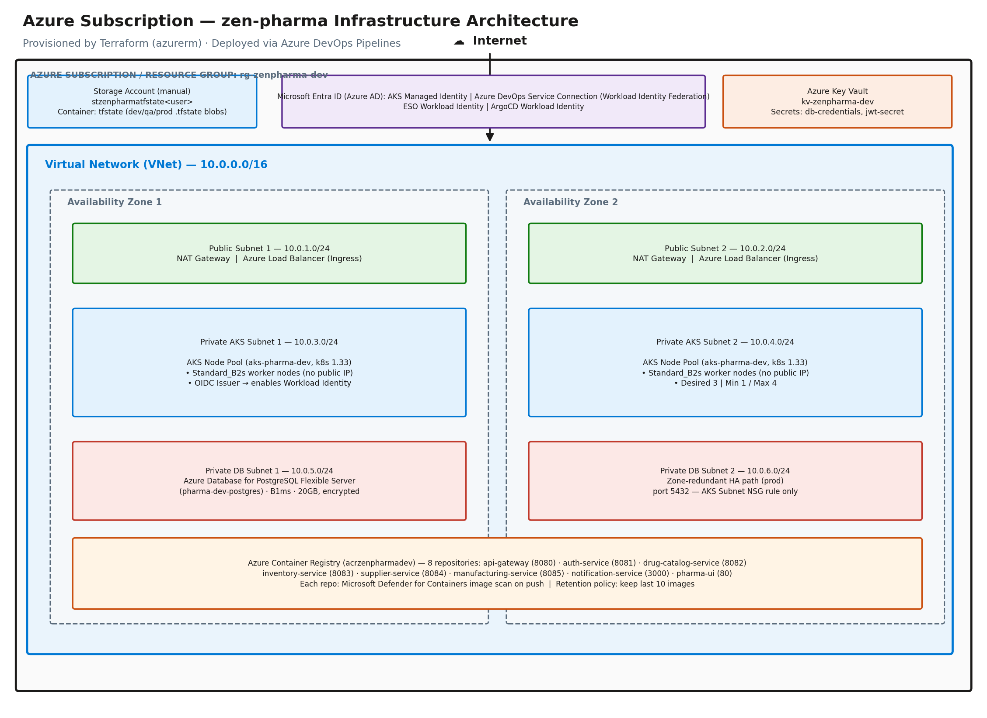
Figure 5. Azure resources created by Terraform for zen-infra (dev environment) — VNet, subnets, AKS, Azure Database for PostgreSQL, ACR, Entra ID, and Key Vault.

Azure Resources Created by Terraform
Azure Subscription (Resource Group: rg-zenpharma-dev, region: East US)
|
+-- Storage Account (created manually - state backend for Terraform)
| +-- stzenpharmatfstate<user> (container: tfstate)
| +-- envs/dev.terraform.tfstate
| +-- envs/qa.terraform.tfstate
| +-- envs/prod.terraform.tfstate
|
+-- Virtual Network (10.0.0.0/16)
| +-- Public Subnets 10.0.1.0/24 (AZ1) ] NAT Gateway,
| | 10.0.2.0/24 (AZ2) ] Load Balancer, Ingress
| +-- Private AKS Subnets 10.0.3.0/24 (AZ1) ] AKS worker
| | 10.0.4.0/24 (AZ2) ] nodes (private)
| +-- Private DB Subnets 10.0.5.0/24 (AZ1) ] Azure DB for PostgreSQL
| 10.0.6.0/24 (AZ2) ] (private, delegated)
|
+-- AKS Cluster (aks-pharma-dev, Kubernetes 1.33)
| +-- Default Node Pool
| | +-- VM size : Standard_B2s
| | +-- Desired : 3 nodes
| | +-- Min / Max : 1 / 4
| | +-- Subnet : private AKS subnets (no public IP)
| +-- OIDC Issuer
| +-- Enables Microsoft Entra Workload Identity - pods assume
| identities without static credentials
|
+-- Azure Database for PostgreSQL - Flexible Server (pharma-dev-postgres)
| +-- Engine : PostgreSQL 15
| +-- SKU : Standard_B1ms (Burstable)
| +-- Storage : 20 GB, encrypted at rest
| +-- Access : private (VNet-integrated), port 5432 from AKS subnet NSG only
| +-- DB name : pharmadb / Admin user: pharmaadmin
|
+-- Azure Container Registry (acrzenpharmadev - 8 repositories, one per service)
| +-- api-gateway (Spring Cloud Gateway, port 8080)
| +-- auth-service (JWT auth, port 8081)
| +-- drug-catalog-service (drug catalogue, port 8082)
| +-- inventory-service (stock management, port 8083)
| +-- supplier-service (vendor management, port 8084)
| +-- manufacturing-service (batch tracking, port 8085)
| +-- notification-service (Node.js, port 3000)
| +-- pharma-ui (React frontend, port 80)
| |
| +-- Each repo has:
| +-- Microsoft Defender for Containers scan on push
| +-- Retention policy (keep last 10 images, purge older ones)
|
+-- Microsoft Entra ID
| +-- AKS Cluster Managed Identity (manages Azure resources for the control plane)
| +-- AKS Kubelet Identity (allows worker nodes to pull from ACR, join cluster)
| |
| +-- Azure DevOps Service Connection (sp-zenpharma-devops, Workload Identity Federation)
| | +-- Federated credential : repo zen-pharma-frontend and zen-pharma-backend only
| | +-- Role assignment : AcrPush/AcrPull on ACR, Reader on AKS
| | +-- How it works : Azure Pipelines OIDC token -> Entra ID -> short-lived token
| | No service principal secret stored in Azure DevOps
| |
| +-- ESO Workload Identity (federated to external-secrets service account)
| | +-- Role assignment : Key Vault Secrets User on kv-zenpharma-dev
| |
| +-- ArgoCD Workload Identity (federated to argocd-application-controller SA)
|
+-- Azure Key Vault
+-- db-credentials {"username": "pharmaadmin", "password": "..."}
+-- jwt-secret {"secret": "..."}

Terraform Module Structure (Azure)
zen-infra-azure/
+-- envs/
| +-- dev/ <-- calls all modules with dev-specific values
| +-- qa/ <-- same modules, different sizing
| +-- prod/ <-- same modules, production sizing + HA settings
|
+-- modules/
+-- network/ creates VNet, subnets, NSGs, NAT Gateway, route tables
+-- aks/ creates AKS cluster, node pool, OIDC issuer
+-- postgresql/ creates Azure Database for PostgreSQL, private DNS zone
+-- acr/ creates Azure Container Registry with retention policy
+-- identity/ creates App Registrations / Managed Identities for Azure DevOps, ESO, ArgoCD
+-- keyvault/ stores DB password and JWT secret in Key Vault

Network Traffic Flow (Azure)
Identical routing logic to Section 1 — only the load balancer and secret store differ:
Internet
|
v
Azure Load Balancer (Standard SKU, created by NGINX Ingress Controller Helm chart)
| routes by URL path
|-- / --> pharma-ui (React, port 80)
|-- /api/* --> api-gateway (port 8080)
|
|-- /api/auth/* --> auth-service (8081)
|-- /api/catalog/* --> drug-catalog-svc (8082)
|-- /api/inventory/* --> inventory-service (8083)
|-- /api/suppliers/* --> supplier-service (8084)
|-- /api/manufacturing/* --> manufacturing-svc (8085)
+-- /api/notifications/* --> notification-svc (3000)
|
All backend services
pull secrets from
Azure Key Vault
via ESO (no passwords
in pod spec or config)
|
v
Azure Database for PostgreSQL (private, VNet-integrated)

Azure DevOps CI/CD Flow for Infrastructure
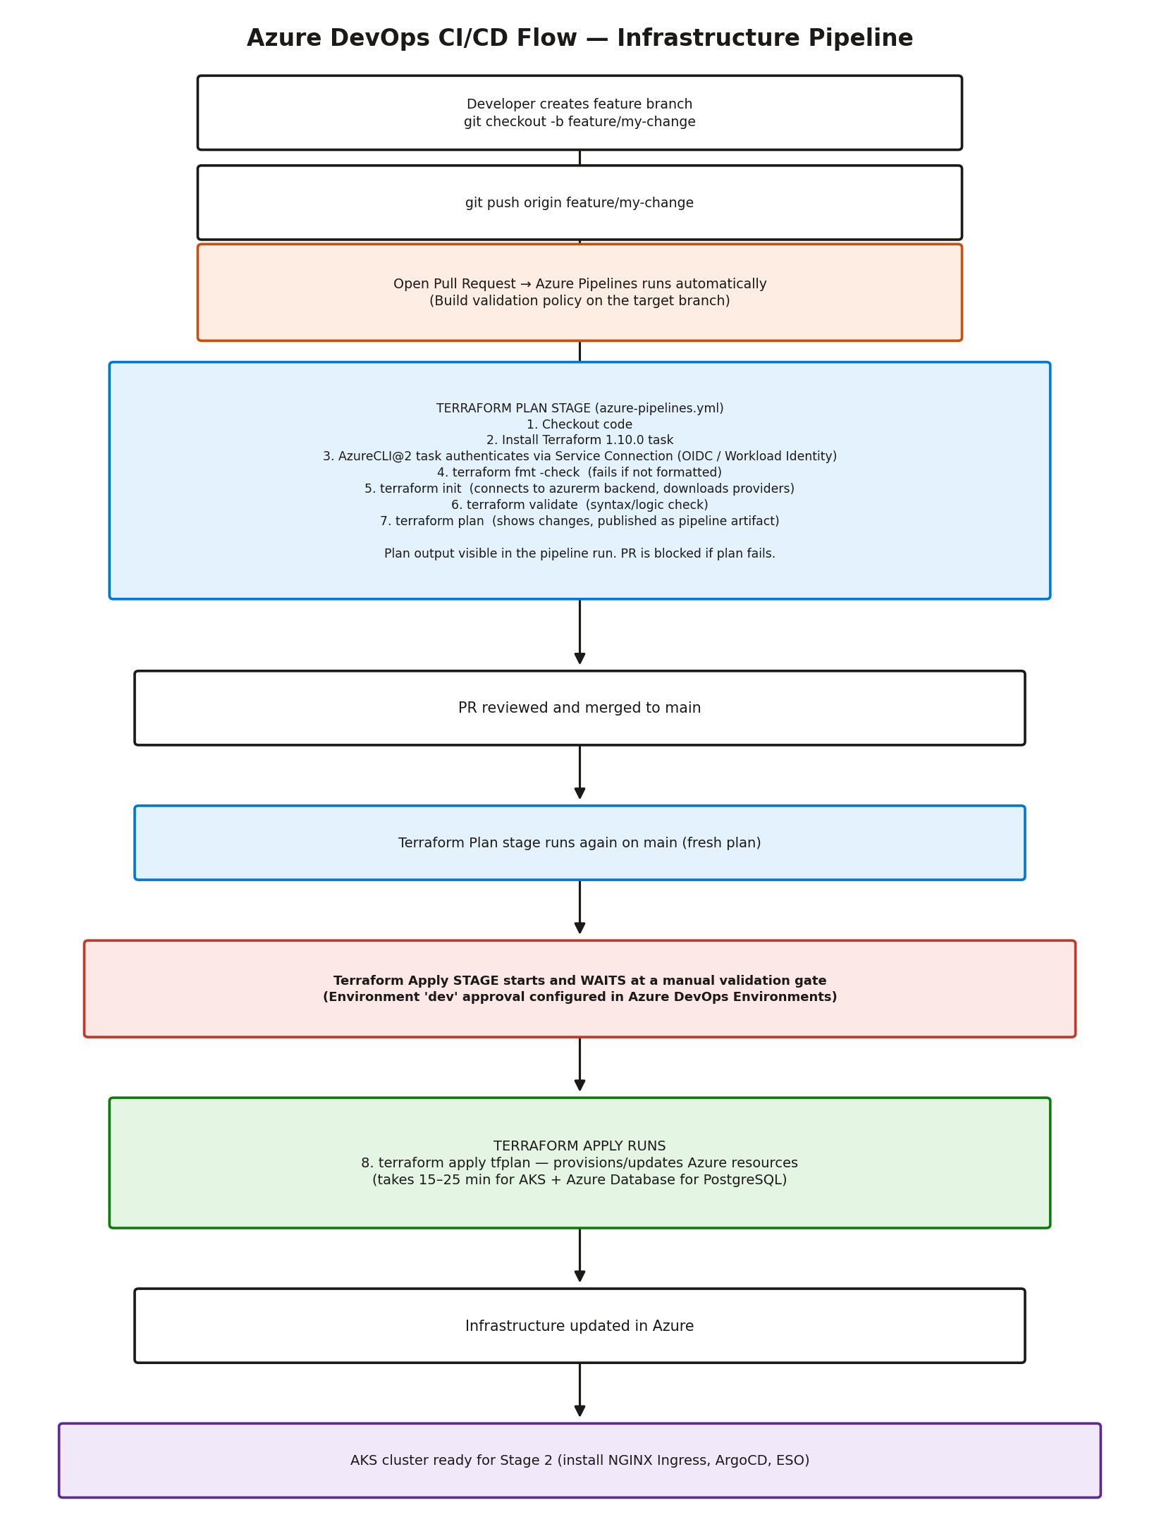
Figure 6. Azure Pipelines flow: plan on PR (build validation), plan again on merge, then an environment-gated apply.
Developer creates feature branch in zen-infra-azure
|
v
git push origin feature/my-change
|
v
Open Pull Request --> Azure Pipelines build-validation policy runs automatically:
|
| [Terraform Plan stage]
| 1. Checkout code
| 2. TerraformInstaller@1 task - install Terraform 1.10.0
| 3. AzureCLI@2 task authenticates via Service Connection (Workload Identity)
| 4. terraform fmt -check --> fails if code is not formatted
| 5. terraform init --> connects to azurerm backend, downloads providers
| 6. terraform validate --> syntax and logic check
| 7. terraform plan --> shows what will change (published as pipeline artifact)
|
| Plan output is visible in the pipeline run. PR is blocked if plan fails.
|
v
PR reviewed and merged to main
|
v
[Terraform Plan stage runs again on main - fresh plan]
|
v
[Terraform Apply stage - WAITS at Environment 'dev' approval gate]
|
| Go to: Pipelines --> running pipeline --> "Review" --> Approve
|
v
[Terraform Apply runs]
| 8. terraform apply tfplan --> provisions/updates Azure resources
| (takes 15-25 min for AKS + Azure Database for PostgreSQL)
|
v
Infrastructure updated in Azure
|
v
AKS cluster is ready for Stage 2 (install NGINX Ingress, ArgoCD, ESO)

Security Design Decisions (Azure)
Decision | Why
Worker nodes in private subnets | Nodes not reachable from internet; only the Load Balancer is public
Azure Database for PostgreSQL in private subnet | Database never exposed to internet; only AKS nodes can connect (port 5432 via NSG rule)
No static service principal secrets in Azure DevOps | Azure Pipelines uses Workload Identity Federation; tokens are short-lived and scoped to specific repos
Workload Identity for pods | Pods never hold Azure credentials; they exchange a projected K8s token for a short-lived Entra ID token
Key Vault (not ConfigMap) | DB passwords and JWT secret never live in Git or Kubernetes config; ESO syncs them at runtime
Defender for Containers scan on push | Every image is automatically scanned for CVEs when pushed; results visible in Microsoft Defender for Cloud
Storage Account with blob versioning | Terraform state is versioned — accidental corruption can be rolled back

20. Step 1 (Azure) — Azure Subscription Setup

20.1 Create a Service Principal for Terraform (bootstrap)
For the initial bootstrap (before Workload Identity Federation is set up via Terraform), you need a Service Principal with Contributor access.
Using Azure CLI:
az login
az account set --subscription "<YOUR-SUBSCRIPTION-ID>"

az ad sp create-for-rbac \
--name "terraform-ci" \
--role "Contributor" \
--scopes "/subscriptions/<YOUR-SUBSCRIPTION-ID>"

# Returns: appId (client id), password (client secret), tenant

Save the appId, password, and tenant — you will need these in Step 5 (Azure DevOps Service Connection setup).
Note: For production: Scope the Service Principal role assignment to only the resource group Terraform manages, and prefer Workload Identity Federation over a client secret.

20.2 Configure Azure CLI Locally
az login
az account show
# Should return your subscription id, tenant id, and user

21. Step 2 (Azure) — Storage Account State Backend Setup
Terraform requires a Storage Account and blob container to store its state file. This must exist before running Terraform. Create it manually — you only do this once.

21.1 Create the Resource Group and Storage Account
Replace YOUR-GITHUB-USERNAME with your actual GitHub/Azure DevOps username to make the storage account name unique.
# Create the resource group
az group create \
--name rg-zenpharma-tfstate \
--location eastus

# Create the storage account
az storage account create \
--name stzenpharmatfstateYOURUSER \
--resource-group rg-zenpharma-tfstate \
--location eastus \
--sku Standard_LRS \
--encryption-services blob

# Enable blob versioning (allows state rollback)
az storage account blob-service-properties update \
--account-name stzenpharmatfstateYOURUSER \
--enable-versioning true

# Block all public access
az storage account update \
--name stzenpharmatfstateYOURUSER \
--resource-group rg-zenpharma-tfstate \
--allow-blob-public-access false

# Create the blob container
az storage container create \
--name tfstate \
--account-name stzenpharmatfstateYOURUSER

21.2 Verify the Storage Account
az storage container list \
--account-name stzenpharmatfstateYOURUSER \
--output table
# Should show the "tfstate" container

22. Step 3 (Azure) — Fork and Configure the Repository

22.1 Fork the Repository
- Go to github.com/your-github-username/zen-infra-azure
- Click Fork (top right)
- Select your account as the destination
- Clone your fork locally, then import it into Azure Repos (or connect Azure Pipelines directly to the GitHub fork):
git clone https://github.com/YOUR-GITHUB-USERNAME/zen-infra-azure.git
cd zen-infra-azure

23. Step 4 (Azure) — Update Configuration for Your Account
You need to update the same four categories of files, adapted for Azure naming.

23.1 Update Backend Configuration
Update the storage account name in all three environment backend files:
envs/dev/backend.tf
terraform {
backend "azurerm" {
resource_group_name = "rg-zenpharma-tfstate"
storage_account_name = "stzenpharmatfstateYOURUSER"
container_name = "tfstate"
key = "envs/dev.terraform.tfstate"
}
}

envs/qa/backend.tf — same change, key stays envs/qa.terraform.tfstate
envs/prod/backend.tf — same change, key stays envs/prod.terraform.tfstate

23.2 Update Azure DevOps Organisation Variable
In envs/dev/variables.tf, update the default value for the org/project reference:
variable "devops_org" {
description = "Azure DevOps organization or GitHub username"
type = string
default = "YOUR-GITHUB-USERNAME" # <- change this
}

Do the same in envs/qa/variables.tf and envs/prod/variables.tf.

23.3 Update the Azure Pipelines Workflow
In azure-pipelines.yml, update the org value:
- script: |
terraform plan \
-var="db_password=$(DEV_DB_PASSWORD)" \
-var="jwt_secret=$(DEV_JWT_SECRET)" \
-var="devops_org=YOUR-GITHUB-USERNAME" \ # <- change this
-out=tfplan \
-no-color
displayName: 'Terraform Plan'

23.4 Commit and Push Changes
git add envs/dev/backend.tf envs/qa/backend.tf envs/prod/backend.tf
git add envs/dev/variables.tf envs/qa/variables.tf envs/prod/variables.tf
git add azure-pipelines.yml
git commit -m "config: update storage account name and org for my account"
git push origin main

24. Step 5 (Azure) — Azure DevOps Service Connection & Variable Group Setup
The pipeline needs Azure credentials and application secrets to run Terraform. These are stored as an Azure DevOps Service Connection (for auth) and a secret-backed Variable Group — never in code.

24.1 Create the Service Connection
Go to your Azure DevOps project: Project Settings → Service connections → New service connection → Azure Resource Manager → Workload identity federation (recommended).
- Scope level: Subscription
- Service connection name: sp-zenpharma-devops
- Grant access permission to all pipelines: leave unchecked; grant explicitly per pipeline for least privilege

24.2 Add Pipeline Variables / Variable Group
Go to Pipelines → Library → + Variable group. Create a group named zenpharma-dev-secrets and add the following, marking each as secret:
Variable Name | Value | Description
AZURE_CLIENT_ID | App registration (Service Connection) client ID | Azure authentication for Terraform
AZURE_TENANT_ID | Your Entra ID tenant ID | Azure authentication for Terraform
DEV_DB_PASSWORD | A strong password (min 8 chars) | PostgreSQL Flexible Server admin password
DEV_JWT_SECRET | A long random string | JWT signing secret for the app

Generating a strong random secret:
openssl rand -hex 32

Note: Once set as secret variables, values are masked in logs and not retrievable through the UI. Store originals in a password manager.

25. Step 6 (Azure) — Azure DevOps Environment Setup
Azure DevOps Environments add an approval gate before terraform apply runs — the direct equivalent of GitHub Environments in Section 9. This ensures a human reviews the plan before infrastructure changes are applied.

25.1 Create the Dev Environment
Go to your Azure DevOps project: Pipelines → Environments → New environment
- Name: dev
- Resource: None
- Click Create

25.2 Add Approval Check
Open the dev environment → ⋮ (more actions) → Approvals and checks → + → Approvals:
- Add your Azure DevOps user/group as an approver
- Leave "Allow approvers to approve their own runs" enabled (you are a solo learner)
- Click Create

25.3 What This Does
When the pipeline runs after a merge to main:
- 1. The plan stage runs automatically
- 2. The apply stage starts but waits — Azure Pipelines shows a pending approval on the dev environment
- 3. You review the plan in the pipeline logs
- 4. You click Review → Approve
- 5. terraform apply runs
This prevents accidental infrastructure changes — even if bad code merges to main, a human must approve before anything changes in Azure.

26. Step 7 (Azure) — Provision Infrastructure via Pipeline
With everything configured, you are ready to provision the infrastructure.

26.1 Create a Feature Branch
Never push directly to main for infrastructure changes. Use a PR:
git checkout -b feature/initial-setup

Make a small change to trigger the pipeline — for example, add a comment to envs/dev/main.tf:
# Initial dev environment setup
data "azurerm_client_config" "current" {}

git add envs/dev/main.tf
git commit -m "feat: initial dev environment setup"
git push origin feature/initial-setup

26.2 Open a Pull Request
Go to your fork/repo and open a PR from feature/initial-setup → main.
The Terraform Plan stage will run automatically as a build validation check. After a few minutes, check the pipeline run to see the plan output. Verify:
- Plan: X to add, 0 to change, 0 to destroy
- No unexpected changes or errors

26.3 Merge the PR
Once the plan looks correct, merge the PR. This triggers the pipeline on main:
- 1. Plan stage runs again (fresh plan on merge)
- 2. Apply stage starts and waits for the dev environment approval
- 3. Go to Pipelines → the running pipeline → Review
- 4. Click Approve

26.4 Wait for Apply to Complete
The apply will take 15–25 minutes because:
- AKS cluster creation: ~10 minutes
- AKS node pool provisioning: ~5 minutes
- Azure Database for PostgreSQL creation: ~5 minutes
Warning: Do not cancel the job — a cancelled mid-apply leaves partial state.
Monitor progress in Pipelines → the running pipeline → Terraform Apply stage.

27. Step 8 (Azure) — Verify the Infrastructure
After apply completes, verify everything was created correctly.

27.1 Check Terraform Outputs
The apply stage logs will show outputs at the end:
Apply complete! Resources: 42 added, 0 changed, 0 destroyed.

Outputs:

aks_cluster_name = "aks-pharma-dev"
postgres_fqdn = "pharma-dev-postgres.postgres.database.azure.com"

27.2 Verify in Azure Portal

AKS:
- Go to Azure Portal → Kubernetes services
- Verify aks-pharma-dev status is Running
- Click the cluster → Node pools → verify node pool shows 3 nodes Ready

Azure Database for PostgreSQL:
- Go to Azure Portal → Azure Database for PostgreSQL flexible servers
- Verify pharma-dev-postgres status is Available

Azure Container Registry:
- Go to Azure Portal → Container registries → acrzenpharmadev → Repositories
- Verify 5 repositories exist: api-gateway, auth-service, pharma-ui, notification-service, drug-catalog-service

Key Vault:
- Go to Azure Portal → Key vaults → kv-zenpharma-dev → Secrets
- Verify db-credentials and jwt-secret exist
Note: Screenshot placeholder — as in Section 11, capture and paste an actual Azure Portal screenshot at each of the four checkpoints above (Kubernetes services list, PostgreSQL flexible servers list, Container registry repositories, Key Vault secrets list) during the live run, so the completed run book serves as verifiable evidence of the POC.

27.3 Connect to the AKS Cluster Locally
# Update local kubeconfig
az aks get-credentials \
--resource-group rg-zenpharma-dev \
--name aks-pharma-dev

# Verify connection
kubectl get nodes
# Should show 3 nodes in Ready state

kubectl get namespaces
# Should show default, kube-system, kube-public, kube-node-lease

28. Infrastructure Details (Azure)

28.1 Networking
Resource | Value | Purpose
VNet address space | 10.0.0.0/16 | Main network
Public Subnet 1 | 10.0.1.0/24 (AZ1) | NAT Gateway, Load Balancer
Public Subnet 2 | 10.0.2.0/24 (AZ2) | NAT Gateway, Load Balancer
Private AKS Subnet 1 | 10.0.3.0/24 (AZ1) | AKS worker nodes
Private AKS Subnet 2 | 10.0.4.0/24 (AZ2) | AKS worker nodes
Private DB Subnet 1 | 10.0.5.0/24 (AZ1) | Azure Database for PostgreSQL
Private DB Subnet 2 | 10.0.6.0/24 (AZ2) | Azure Database for PostgreSQL

Worker nodes and the database are in private subnets — no direct internet access. Outbound traffic routes through the NAT Gateway.

28.2 AKS Cluster
Setting | Dev Value | Notes
Cluster version | 1.33 | Update periodically
Node VM size | Standard_B2s | Cost-optimised for dev
Desired nodes | 3 | Adjust based on workload
Min nodes | 2 | Minimum for HA (cluster autoscaler)
Max nodes | 4 | Auto-scaling ceiling
OIDC issuer | Enabled | Required for Workload Identity

28.3 Azure Database for PostgreSQL
Setting | Dev Value | Prod Value
Engine version | 15 | 15
SKU / Tier | Standard_B1ms (Burstable) | Larger (General Purpose+)
Storage | 20 GB | More, with autogrow
Zone redundant HA | No | Yes
Backup retention | 7 days (minimum) | 35 days
Deletion protection | No | Yes
Encryption | Yes (platform-managed) | Yes (customer-managed optional)
Public network access | Disabled | Disabled

Azure Database for PostgreSQL is only accessible from AKS worker nodes via the subnet NSG — port 5432 from the AKS subnet only.

28.4 Azure Container Registry
The registry (acrzenpharmadev) has:
- Standard SKU — supports geo-features and higher throughput than Basic
- Microsoft Defender for Containers — automatic vulnerability scanning on every push
- Retention policy: keep last 10 images per repository, purge older ones automatically

28.5 Azure DevOps Workload Identity Federation
The identity module creates a Microsoft Entra ID App Registration with a federated credential that allows CI/CD pipelines in zen-pharma-frontend and zen-pharma-backend to push images to ACR without storing a service principal secret in Azure DevOps.
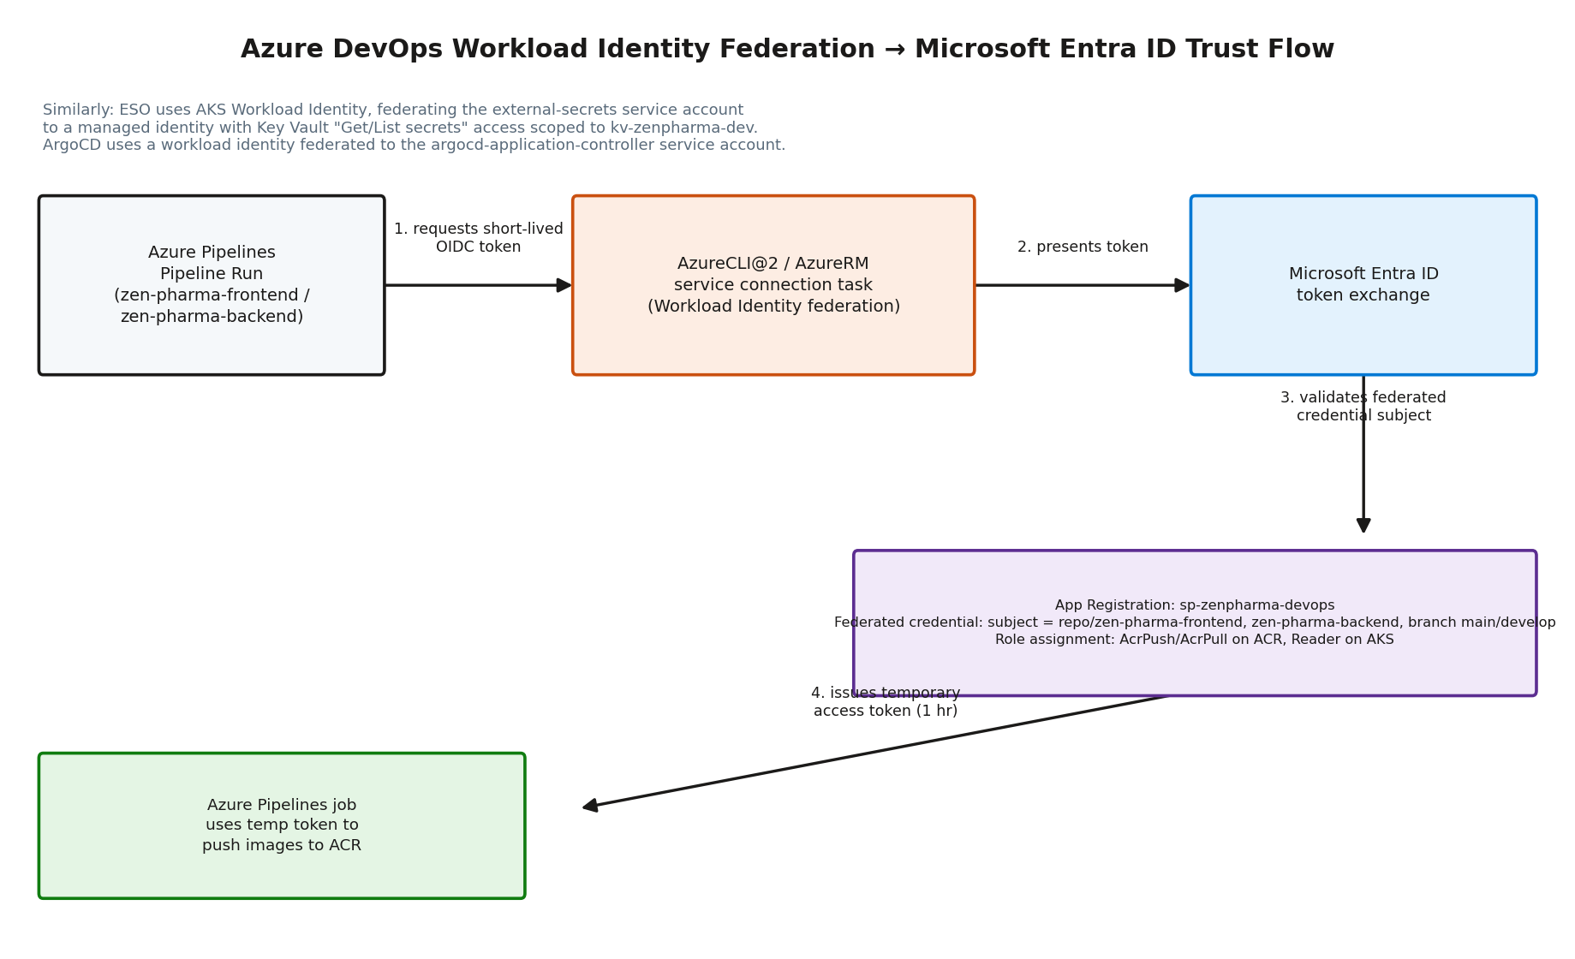
Figure 7. Azure Pipelines OIDC token exchanged for a short-lived Entra ID access token via the federated credential.
How it works:
- 1. Azure Pipelines requests a short-lived OIDC token per pipeline run
- 2. The AzureCLI@2 / AzureRM task presents the token to the Service Connection
- 3. Microsoft Entra ID validates the token against the federated credential subject and issues a temporary access token (1 hour)
- 4. The pipeline uses this token to push images to ACR
The federated credential is restricted to:
- Only YOUR-GITHUB-USERNAME/zen-pharma-frontend and YOUR-GITHUB-USERNAME/zen-pharma-backend repos
- Only main and develop branches

29. Day-2 Operations (Azure)

Making Infrastructure Changes
Always use the PR-based flow:
# 1. Create a branch
git checkout -b feature/your-change

# 2. Make your Terraform changes
# Edit files in envs/dev/ or modules/

# 3. Test locally first
cd envs/dev
terraform init
terraform plan \
-var="db_password=test" \
-var="jwt_secret=test"

# 4. Push and open a PR
git add .
git commit -m "describe your change"
git push origin feature/your-change
# Open PR -> Azure Pipelines build validation runs automatically

# 5. Review the plan in the pipeline logs
# 6. Merge if plan is correct -> approve apply on the dev environment

Scaling the AKS Node Pool
Edit envs/dev/main.tf:
module "aks" {
...
node_count = 5 # <- change this
min_count = 3
max_count = 8
}

Open a PR, review the plan (should show AKS node pool update), merge, approve apply.

Adding a New ACR Repository
Edit envs/dev/main.tf:
module "acr" {
...
repositories = [
"api-gateway",
"auth-service",
"pharma-ui",
"notification-service",
"drug-catalog-service",
"new-service" # <- add here
]
}

Plan will show 2 new resources: the new repository retention policy and its associated RBAC scope map entry.

Checking State
cd envs/dev

# List all resources in state
terraform state list

# Inspect a specific resource
terraform state show module.aks.azurerm_kubernetes_cluster.main

# Check for drift (what changed in Azure outside Terraform)
terraform plan \
-var="db_password=dummy" \
-var="jwt_secret=dummy"

30. Destroying Infrastructure (Azure)
Warning: This permanently deletes all infrastructure including the AKS cluster, PostgreSQL database, and all data. There is no undo.

Via Pipeline (Recommended)
- 1. Go to your Azure DevOps project → Pipelines
- 2. Select the Terraform Infrastructure pipeline
- 3. Click Run pipeline
- 4. Set:
  - Terraform action: destroy
  - Type "destroy" to confirm: destroy
- 5. Click Run
- 6. The destroy stage will wait at the environment approval gate — review then approve
- 7. Wait 15–25 minutes for all resources to be deleted

Locally (Alternative)
cd envs/dev
terraform init
terraform destroy \
-var="db_password=dummy" \
-var="jwt_secret=dummy" \
-var="devops_org=YOUR-GITHUB-USERNAME"

Type yes when prompted.

After Destroying
The Storage Account state container is not deleted by Terraform destroy — it is managed separately. To delete it:
# Delete all blobs in the container first
az storage blob delete-batch \
--account-name stzenpharmatfstateYOURUSER \
--source tfstate

# Delete the storage account
az storage account delete \
--name stzenpharmatfstateYOURUSER \
--resource-group rg-zenpharma-tfstate \
--yes

31. Troubleshooting (Azure)

Plan shows resources already exist (RegistryAlreadyExistsException-equivalent)
ACR repositories/images can conflict if you recreated the stack after a destroy and the registry itself was not fully purged.

Fix — purge repositories manually then re-run:
for repo in api-gateway auth-service pharma-ui notification-service drug-catalog-service; do
az acr repository delete \
--name acrzenpharmadev \
--repository $repo \
--yes
done

Then re-trigger the pipeline.

Apply failed halfway through
Do not panic. Terraform updates state for every resource it successfully creates.
- 1. Read the error in the pipeline logs (expand the Apply stage, scroll up from the bottom)
- 2. Fix the root cause
- 3. Re-trigger the pipeline — it will continue from where it left off

State lock error
Error: Error acquiring the state lock

Another apply is running (or a previous one crashed mid-run). Wait for it to finish. If you are certain no apply is running:
cd envs/dev
terraform force-unlock <LOCK-ID>
# Lock ID is shown in the error message

terraform init fails — storage account/container does not exist
You have not created the Storage Account or blob container yet. Follow Step 2 (Section 21 of this run book).

AKS nodes not joining the cluster
kubectl get nodes
# Shows nodes in NotReady state

Check the AKS Kubelet identity has the required role assignments:
- AcrPull on the Azure Container Registry
- Network Contributor on the AKS subnet (if using a custom VNet)
These are attached automatically by Terraform. If nodes are not joining, the apply may not have completed fully — check the apply logs.

Pipeline apply stage is skipped
The apply stage only runs on:
- Push/merge to main when envs/dev/** or modules/** files changed (path filters / triggers)
- Manual pipeline run with parameter action: apply
If you only changed pipeline definition files (azure-pipelines.yml), the path filter may prevent the pipeline from triggering.

Cannot connect to AKS cluster locally
# Re-fetch credentials
az aks get-credentials --resource-group rg-zenpharma-dev --name aks-pharma-dev --overwrite-existing

# Check your Azure identity
az account show

# Verify cluster is running
az aks show --resource-group rg-zenpharma-dev --name aks-pharma-dev --query 'provisioningState'

Only the Entra ID identity that created the cluster (the CI/CD Service Connection or your local user) has access by default. If using a different identity locally, you need to add it via az aks get-credentials with appropriate RBAC (Azure Kubernetes Service RBAC Cluster Admin or Reader).

32. Cost Estimate (Azure Dev Environment)
Resource | Approximate Cost
AKS Cluster (control plane, Free tier) | $0/hour (Free tier; Standard tier ~$0.10/hour if selected)
3x Standard_B2s AKS nodes | ~$0.075/hour combined (~$54/month)
Azure Database for PostgreSQL B1ms | ~$0.02/hour (~$14–18/month)
NAT Gateway | ~$0.045/hour (~$32/month) + data processing
Azure Container Registry (Standard) | ~$20/month flat + storage
Azure Key Vault | ~$0.03/10,000 operations (2 secrets ≈ negligible)
Total estimate | ~$150–180/month

Note: For learners: Destroy the infrastructure when not in use. AKS nodes and the NAT Gateway are the largest costs. Use the destroy pipeline at the end of each day and re-provision when needed.
This section covers the Azure dev environment. QA and prod environments follow the same setup process — create the corresponding Azure DevOps Environments with appropriate approval checks and add the corresponding variables (QA_DB_PASSWORD, QA_JWT_SECRET, etc.).

Built with Terraform 1.10+ (azurerm provider) · Azure Pipelines · AKS, Azure Database for PostgreSQL, ACR, VNet, Microsoft Entra ID, Key Vault

